

Waterloo Primary School Art Knowledge Organiser

Topic: Andy Goldsworthy

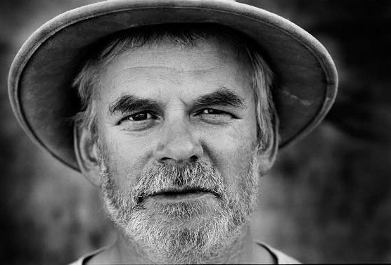

**I will be able to:**

* Describe the work of Andy Goldsworthy (what I can see, colours, patterns, how it makes me feel)
* List natural materials that are easily found in the local environment
* Begin to use my sketchbook
* Make a nature sculpture
* Listen to my teachers and friends. Share my thoughts and ideas.

**I will know:**

* Andy Goldsworthy was a British artist sculpture
* He was inspired by nature and used natural materials
* We can find patterns in nature

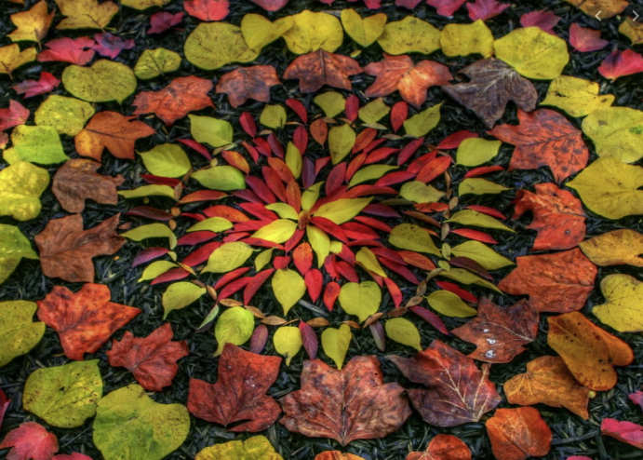

What will I know by the end of this unit of work?

Vocabulary

* How to name different colours and describe patterns and textures
* That I can cut, stick, and build to create models
* That different materials have different features (strength, texture, appearance)
* I can like and dislike works of art

Sculpture- Something made by carving, casting, or other shaping techniques.

Statue- a carved or cast figure of a person or animal, especially one that is life-size or larger.

3D- Something that has volume, a top and bottom, left and right (sides), as well as a front and back.

Natural- existing in or derived from nature, not made or caused by humankind.

Texture- the feel or appearance of a surface or a substance.

Design – a plan or drawing produced to show the look and function or workings of artwork.

Refine – make minor changes to improve our work

Inspired – when something gives you lots of ideas and makes you want to create

Year: 1

What should I already know?