

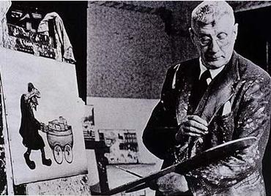

**I will be able to:**

* Mix paint from Lowry colours.
* Draw simple buildings.
* Point out the matchstick figures in Lowry’s paintings.
* Draw simple matchstick figures.

**I will know:**

Lowry was born in 1887, Stretford

Lowry was an English artist famous for paintings about town life

Lowry, was an artist who lived in England and was inspired by his surroundings and the events in his life

He started painting the different images he saw when he was just 15 years old

Lowry often used dull colours.

Topic: L.S. Lowry

What will I know by the end of this unit of work?

Vocabulary

Materials have different features

List natural materials that are easily found in the local environment

That different materials have different features

That you can like and dislike works of art and your friends and teachers might have different ideas.

Lowry Colours- red, black, blue, yellow and white.

Perspective- representing three-dimensional objects on a two-dimensional surface so as to give the right impression of their height, width, depth, and position in relation to each other.

Landscape- all the visible features of an area of land.

Industrial Buildings- Factories and other buildings used to make, repair or take things apart.

Design – a plan or drawing produced to show the look and function or workings of artwork.

Background – part of a picture or design that forms a setting and appears furthest away.

Refine – make minor changes so as to improve our work

Year: 1

What should I already know?

Waterloo Primary School – Art Knowledge Organiser