

Year: 1

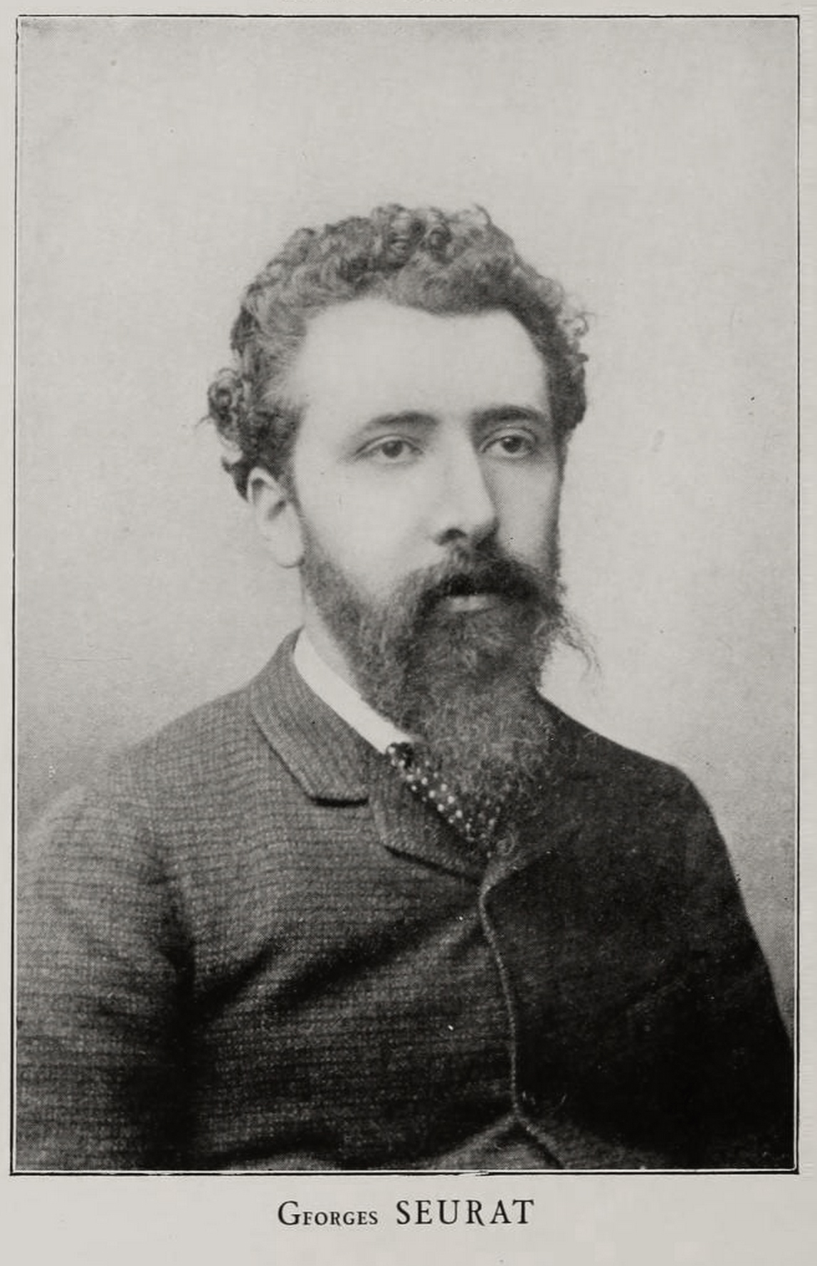

**I will be able to:**

* Describe the works of Georges Seurat
* Explain what pointillism is
* Experiment with pointillism using pencil, felt tips and paint (cotton buds)
* Listen to my friends and teachers
* Share my ideas
* Make refinements to my work based on feedback

**I will know:**

* Georges Seurat was a French painter who lived over 100 years ago
* His was inspired by science and colour
* He painted in tiny dots of colour. This technique is called "pointillism".
* One of his most famous paintings is:

‘A Sunday Afternoon on the Island of La Grande Jatte’

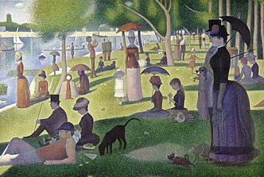

Topic: Georges Seurat

What will I know by the end of this unit of work?

Vocabulary

* How to mix colours
* That paint can be used in different ways
* That Jackson Pollack uses a painting technique
* That artists can be inspired by different things

Technique – a way of doing/creating something

Pointillism- Pointillism is a technique of painting in which small, distinct dots of colour are applied in patterns to form an image

Texture- the feel or appearance of a surface or a substance

Perspective - how artist use size to show how near or far something is

Refine – make minor changes to improve our work

Inspired – when something gives you lots of ideas and makes you want to create

What should I already know?

Waterloo Primary School Art