

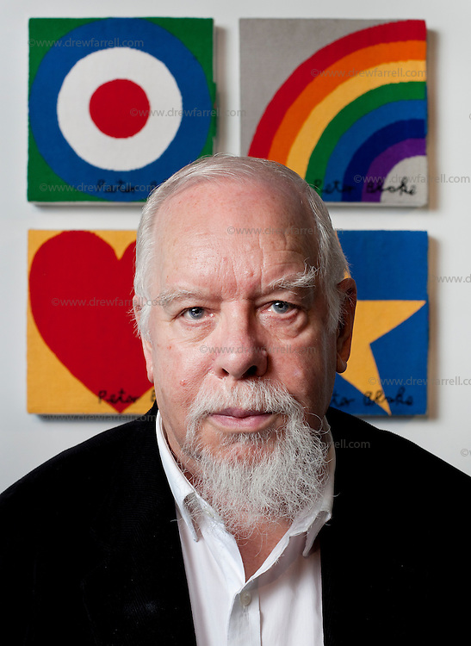

I will be able to:

* Investigate tone by drawing lines, patterns and shapes
* Talk about artwork, expressing likes and dislikes
* Develop and experiment with ideas in my sketchbook
* Develop sketching/drawing skills
* Create my own artwork inspired by Peter Blake
* Review and refine my ideas, developing my skills.

I will know:

Sir Peter Thomas Blake was born: 1932, Dartford

Sir Peter Thomas Blake is an English [pop artist](https://en.wikipedia.org/wiki/Pop_art), best known for co-creating the sleeve design for [the Beatles](https://en.wikipedia.org/wiki/The_Beatles)' album *[Sgt. Pepper's Lonely Hearts Club Band](https://en.wikipedia.org/wiki/Sgt._Pepper%27s_Lonely_Hearts_Club_Band" \o "Sgt. Pepper's Lonely Hearts Club Band).*

Topic: Peter Blake

What will I know by the end of this unit of work?

Vocabulary

How to use my sketchbook to develop my ideas

Some artists and artwork.

How to experiment with and talk about patterns and texture.

Pop Art – art based on modern popular culture and the mass media, especially as a critical or ironic comment on traditional fine art.

Pattern – a repeated decorative design.

Primary Colours – red, yellow and blue.

Design – a plan or drawing produced to show the look and function or workings of artwork.

Background – part of a picture or design that forms a setting and appears furthest away.

Foreground – the part of the view that is nearest the observer.

Portrait- a painting, drawing or photograph of a person

Refine – make minor changes so as to improve our work

Year: 2

What should I already know?

Waterloo Primary School – Art Knowledge Organiser