

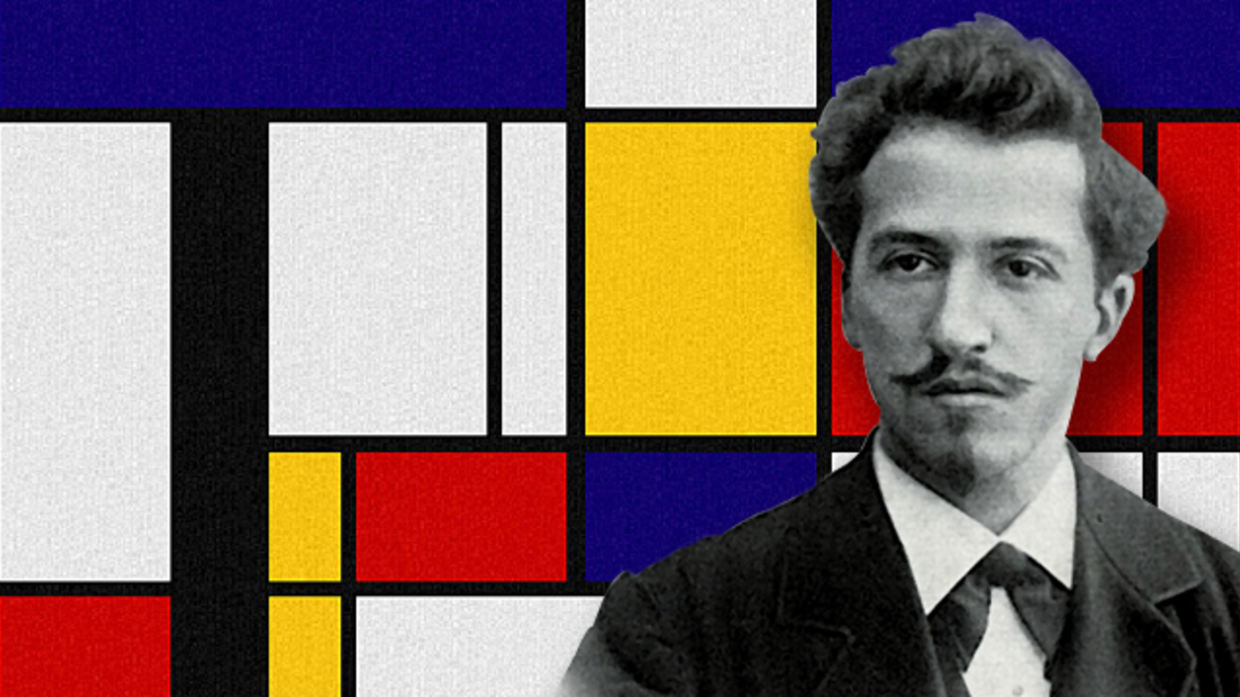

I will be able to:

* Investigate tone by bold lines, patterns and shapes.
* Investigate pattern and paint.
* Reflect on existing artwork and express my viewpoint.
* I will be able to explore and experiment with negative white space, primary colours and bold lines.
* Develop and experiment with ideas in my sketchbook.
* Develop sketching/drawing skills
* Create my own artwork inspired by Piet Mondrian.
* Review and refine my ideas, developing my skills.

Born: 7th March 1872.

Died: 1st February 1944

Mondrian was a Dutch painter who is regarded as one of the greatest artists of the 20th century. He is known for being one of the pioneers of 20th century abstract art, as he changed his artistic direction from figurative painting to an increasingly abstract style, until reaching simple geometric elements.

Pattern – a repeated decorative design.

Design – a plan or drawing produced to show the look and function or workings of artwork.

Refine – make minor changes so as to improve our work

Background – contents at the rear (back) of the image.

Bright/vibrant – colours that are loud or bold in colour.

Bold/ dramatic – artwork that is strong or distinct.

Silhouette – images of a person, object or scene as a solid shape in a single colour usually black.

Blending – the gentle blending of two colours usually seen in painting and drawing.

Media/medium – materials used to create a work of art.

Similarities and differences – what is the same and different

Collage - layering (sticking) and using different media to create different outcomes.

Vocabulary

* How to use my sketchbook
* How to share ideas with adults and children
* Talk about what your work (what you like most)

What should I already know?

Topic: Piet Mondrian

What will I know by the end of this unit of work?

Year: 2

Waterloo Primary School – Art Knowledge Organiser