

Refine – make minor changes so as to improve our work

Painting – the action or skill using paint to create a picture of as decoration.

African art – work inspired by African culture.

Background – contents at the rear (back) of the image.

Bright/vibrant – colours that are loud or bold in colour.

Bold/ dramatic – artwork that is strong or distinct.

Silhouette – images of a person, object or scene as a solid shape in a single colour usually black.

Media/medium – materials used to create a work of art.

Similarities/differences – things that are the same and different

Collage - layering (sticking) and using different media to create different outcomes.

Vocabulary

How to investigate basic colour and tones.

How to discuss and compare different styles and pieces

Have simple sketchbook skills to explore and experiment with ideas.

Begin to plan and refine drawings.

Begin to evaluate work.

What should I already know?

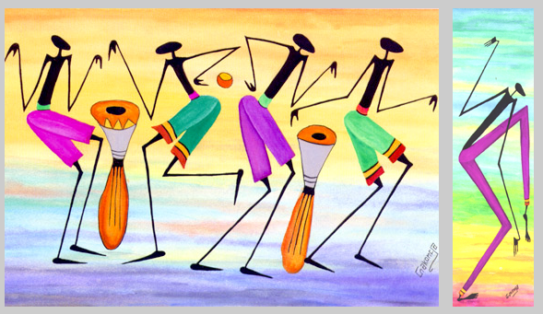

I will be able to:

* Investigate tone and colour by bold lines, patterns and shapes
* Paint and pencil work
* Reflect on existing artwork and express my viewpoint
* I will be able to explore and experiment with different mediums
* Develop and experiment with ideas in my sketchbook
* Develop sketching and painting skills
* Create my own artwork inspired by Gakonga
* Review and refine my ideas, developing my skills

I will know that:

Gakonga was born in Kenya, Africa

Gakonga began by experimenting with plant dyes and sea shells.

His work is inspired by farm life and youthfulness.

His paintings capture and enjoy the magic colours of Kenya.

Topic: Gakonga African Art

What will I know by the end of this unit of work?

Year: 2

Waterloo Primary School – Art Knowledge Organiser