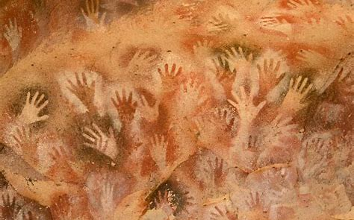

Topic: Cave Art

I will be able to:

* study the history of cave paintings and use examples to inspire my own
* use a sketchbook to record media explorations and experimentations as well as planning and collecting source material for future works
* continue to investigate tone by drawing lines, patterns and shapes with a pencil, considering light and dark
* plan and refine drawings
* discuss own and others’ work, expressing thoughts and feelings, using knowledge and understanding of artists and techniques

**I will know:**

Cave paintings are [paintings](https://wiki.kidzsearch.com/wiki/Painting) on [cave](https://wiki.kidzsearch.com/wiki/Cave) walls and ceilings. Usually, these paintings were made in [prehistoric](https://wiki.kidzsearch.com/wiki/Prehistoric) times. Most cave paintings date from 10,000 to 20,000 years ago

Most people think they may have had a function for [rituals](https://wiki.kidzsearch.com/wiki/Ritual)

Most often, [animals](https://wiki.kidzsearch.com/wiki/Animal) or hunting scenes were painted. Sometimes hands too. Rarely, there were also more [abstract](https://wiki.kidzsearch.com/wiki/Abstract_art) patterns.

The paintings were drawn with red and yellow [ochre](https://wiki.kidzsearch.com/wiki/Ochre), [hematite](https://wiki.kidzsearch.com/wiki/Hematite), [manganese oxide](https://wiki.kidzsearch.com/wiki/Manganese_oxide) and [charcoal](https://wiki.kidzsearch.com/wiki/Charcoal).

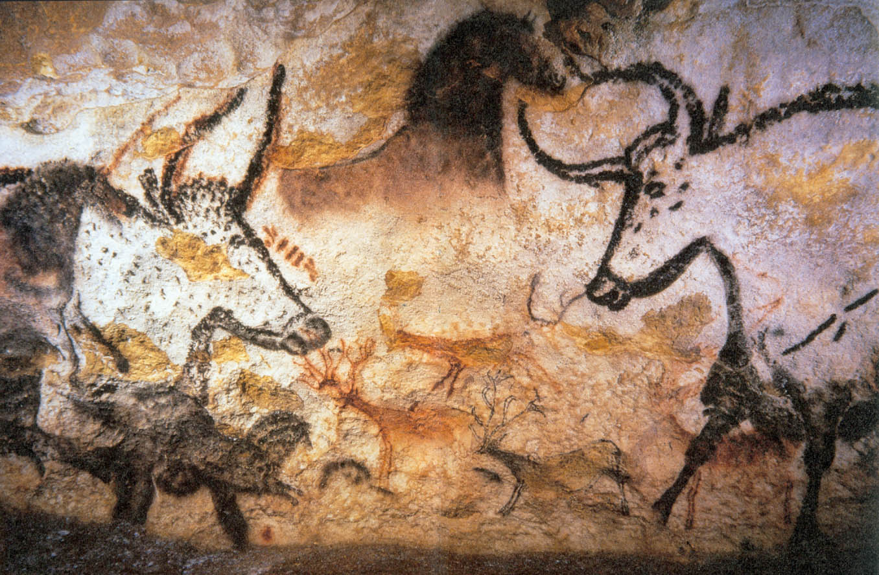

What will I know by the end of this unit of work?

Vocabulary

* How to use a sketchbook to develop ideas
* Facts about different famous artists
* That culture influences art
* How to use: hatching, scribbling, stippling and bending to create light and dark

Cave Art - **paintings and engravings on the walls of caves and rock-shelters**, especially naturalistic depictions of animals

Perspective- the illusion of depth or space in a painting or drawing

Shade – darken or colour with parallel pencil lines or a block of colour

Observation – drawing what you see

Refine – make minor changes so as to improve our work

Tone - the **degree of lightness or darkness of an area**

Blend **–** mix (a substance) with another substance so that they combine together

Pattern – arepeated decorative design.

Year: 3

What should I already know?

Waterloo Primary School – Art Knowledge Organiser