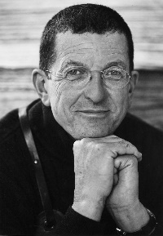

Year: 3

Topic: Anthony Gormley- Iron Men

I will be able to:

* use a sketchbook to record media explorations and experimentations as well as planning and collecting source material for future works
* improve drawing and sketching skills from observation
* talk about artist Antony Gormley and his sculptures - the ironmen and his other works
* continue to investigate tone by drawing lines, patterns and shapes with a pencil, considering light and dark
* plan and refine drawings
* discuss own and others’ work, expressing thoughts and feelings, using knowledge and understanding of artists and techniques

**I will know:**

* Anthony Gormlay was born in 1950 in [London](http://primaryfacts.com/london-facts-information-and-resources/), England.
* His mother was German, his father was Irish and he had six siblings.
* He grew up in Dewsbury Moor in West Yorkshire.
* Antony Gormley went to Ampleforth College, a boarding school, and then he went to Trinity College in Cambridge to study archaeology, anthropology and history of art.
* His first solo exhibition was in 1981 at Whitechapel Art Gallery.
* Most of his sculpture work is based around the form of the human body.
* He won the Turner Prize in 1994 for his work *Field for the British Isles*. This work features 35,000 terracotta figures.
* His most famous work is the [*Angel of the North*](http://primaryfacts.com/2532/angel-of-the-north-facts-and-information/), a steel sculpture (measuring 20 metres tall), located in Gateshead.

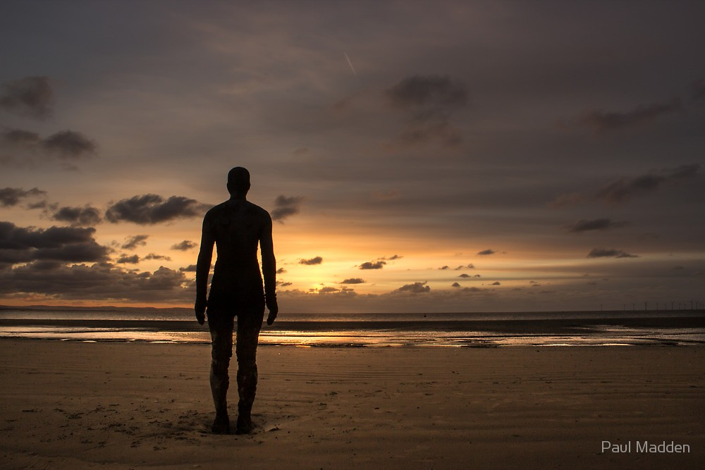

What will I know by the end of this unit of work?

Vocabulary

* a sketchbook is used to develop ideas
* different techniques produce different results
* how to develop tone using a pencil: hatching, scribbling, stippling and bending to create light and dark
* how to discuss own and others’ work, expressing their opinions

Sculpture - the art of making two- or three-dimensional representative or abstract forms, especially by carving stone or wood or by casting metal or plaster

2D – two dimensional - having or appearing to have length and breadth but no depth

3D – three dimensional - having or appearing to have length, breadth, and depth

Metallic - relating to or resembling metal or metals

Shade – darken or colour with parallel pencil lines or a block of colour

Observation – drawing what you see

Refine – make minor changes so as to improve our work

Tone - the **degree of lightness or darkness of an area**

What should I already know?

Waterloo Primary School – Art Knowledge Organiser