

* different techniques produce different results
* how to design and make their own natural sculpture
* how to discuss own and others’ work, expressing their opinion
* Greek architecture still inspires work today
* How clay feels and how it hardens when it dries

Year: 3

Topic: Greek Architecture - Clay Pots

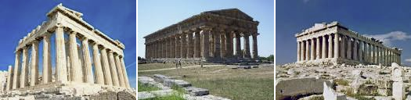

**I will be able to:**

* develop techniques with sculpture using clay
* explain what coiling means
* explain what kneading means
* explain what pinching means
* discuss own and others’ work, expressing thoughts and feelings, using knowledge and understanding of techniques

**I will know:**

* Greek architecture still inspires work today (St George's Hall)
* Ancient Greek buildings include: The Parthenon and The Lindos Acropolis
* historians have found ancient Greek coins, jewellery, masks, and pottery
* Ancient Greek pots are a historical source, providing information about beliefs and practices

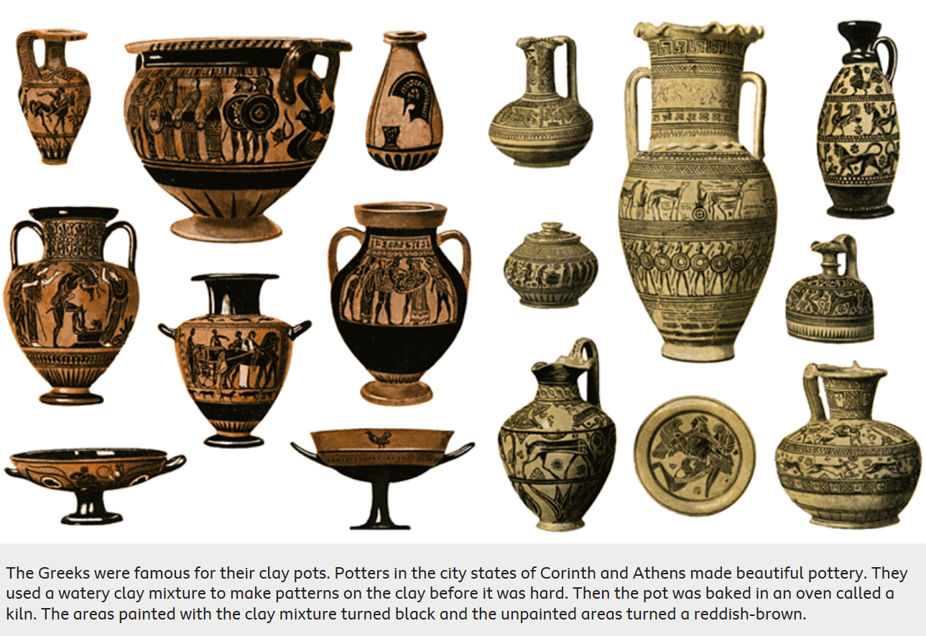

What will I know by the end of this unit of work?

Vocabulary

Sculpture - the art of making two- or three-dimensional representative or abstract forms, especially by carving stone or wood or by casting metal or plaster

Clay – a stiff, sticky fine-grained earth that can be moulded when wet, and is dried and baked to make bricks, pottery, and ceramics

Coiling - building up sides of pots with successive rolls of clay

Kneading - work (moistened flour or clay) into dough or paste with the hands

Pinching - pressing the thumb into a ball of clay, and drawing the clay out by repeatedly squeezing the clay between the thumb and fingers

Slab – a flat, solid block of clay

Refine – make minor changes to improve our work

What should I already know?

Waterloo Primary School – Art Knowledge Organiser