

Topic: Leonardo Da Vinci

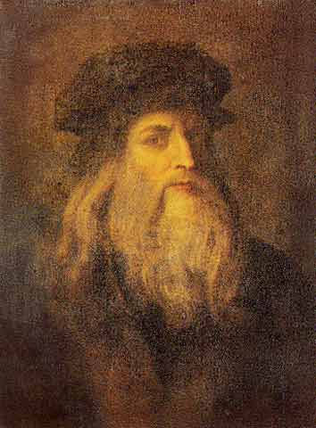 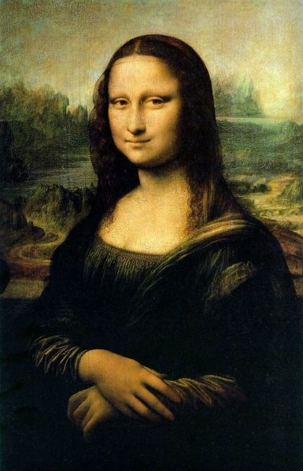

**I will be able to:**

* Improve my drawing and sketching skills from observation
* To study Da Vinci and his techniques
* Discuss the work of Da Vinci, making comparisons with other artists I artists I have studied
* Discuss the work of Da Vinci using subject specific vocabulary
* Produce a portrait in the style of Da Vinci
* Use my sketchbooks to collect and record visual information from different sources as well as planning and collecting source material for future works
* Explore relationships between line and tone, pattern and shape, line and texture
* Identify and create the effect of light and dark
* Experiment with different grades of pencil to achieve variations in tone

**I will know:**

* Born 1452 – Died 1519
* Leonardo Da Vinci was a painter, sculptor, architect, and engineer
* He was an influential artist from the Renaissance period
* It was a time when many advances were made in education, art, science, literature, and music
* He was sometimes called ‘The Renaissance man’ as he was so skilled in many different areas
* The ‘Mona Lisa’ is considered his most famous painting

What will I know by the end of this unit of work?

Vocabulary

* How to use my sketchbook to record media explorations and experimentations as well as planning and collecting source material for future works
* How to experiment with light and dark
* How to plan and refine my drawings

Portrait- a painting, drawing or photograph of a person

Renaissance – means rebirth and is used to mark an era of renewed interest in classical art and ideas of Ancient Greece & Rome

Sfumtao- smokey effect created by Da Vinci

Perspective- the illusion of depth or space in a painting or drawing.

Shade – darken or colour with parallel pencil lines or a block of colour.

Proportions – adjusting design so that it is has a suitable size relative to the rest of the objects

Observation – drawing what you see

Refine – make minor changes to improve our work

Year: 4

What should I already know?

Waterloo Primary School – Art Knowledge Organiser