

Topic: Roman mosaics

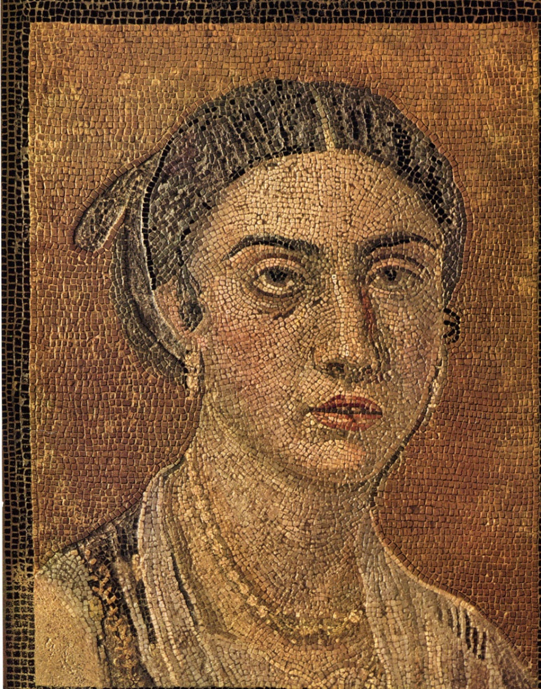 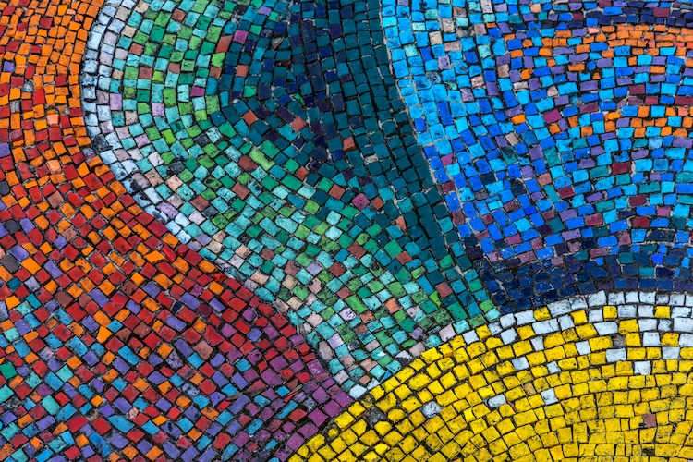

**I will be able to:**

* Use my own historical knowledge and research to explore and create roman style mosaics
* Use my sketchbook to collect and record visual information from different sources as well as planning and collecting source material for future works
* Discuss and define drawings using subject specific vocabulary

**I will know:**

* Mosaic is the [art](https://kids.kiddle.co/Art) of decorating a surface with pictures and patterns made of little pieces of stone, glass or tiles of different colours
* Mosaics can be used indoors on walls, floors and ceilings
* Mosaics are sometimes used outdoors on pavements
* Traditional mosaics are made by setting coloured pieces into "mortar" (cement) which sets hard and holds the pieces in place

What will I know by the end of this unit of work?

Vocabulary

* That the Romans used the art of mosaic to decorate
* How to use my sketchbook to record media explorations and experimentations as well as planning and collecting source material for future works
* How to experiment with light and dark
* How to plan and refine my drawings

Mosaic- A **mosaic** is an artistic picture or design made out of any materials assembled together. Mosaic are used as decoration.

Tesserae – Mosaics were made from tiny coloured stones which they called tesserae

Motor – material used to stick tiles to the floor, it was a type of cement.

Pattern – a repeated decorative design

Opus Sectile – patterned floors made with the larger cut stone tiles.

Hardie – like a chisel, used alongside a hammer to cut the tiles

Intricate – very complicated or detailed

Refine – make minor changes to improve our work

Year: 4

What should I already know?

Waterloo Primary School – Art Knowledge Organiser