

Topic: Recycled sculptures

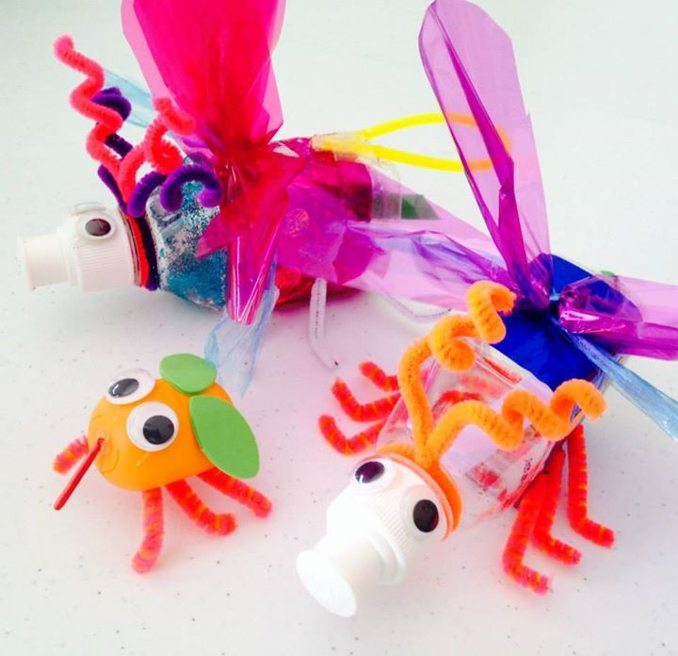

**I will be able to:**

* Improve my mastery of drawing and sketching skills from observation
* Recognise the need for recycling and create a  sculpture to reflect this
* Discuss and make comparisons across a range of known artists
* Discuss and define drawings using subject specific vocabulary
* Combine different materials for effect
* Share and discuss my work with others

**I will know:**

* The importance of recycling and reusing for our environment
* **That items of ‘rubbish’ can be reused to create pieces of art**
* **That art can be interpreted in different ways by different people**

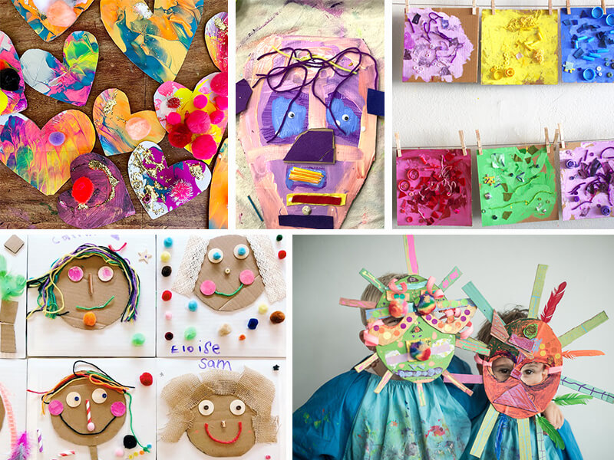

What will I know by the end of this unit of work?

Vocabulary

* The works of famous sculptors (Anthony Gormlay and Andy Goldworthy)
* That different materials would be useful when making sculptures as well as being safe to use.
* How to use a sketchbook to explore and experiment with ideas.
* That ideas can be developed when working collaboratively with peers.

Recycled - having been used before and then put through a [process](https://dictionary.cambridge.org/dictionary/english/process) so that it can [form](https://dictionary.cambridge.org/dictionary/english/form) a new [product](https://dictionary.cambridge.org/dictionary/english/product)

Sculpture – an artistic form in which hard or plastic materials are worked into three-dimensional art objects.

Recycle – to sort and collect rubbish to sort it and produce useful materials that can be used again.

Containers – Any object that can be used to hold things inside it.

Rubbish – waste material that is no longer wanted or needed.

Plastic – an artificial substance that can be shaped when soft into many different forms and has many different uses.

Re-use – use more than once.

Refine – make minor changes so as to improve our work

Year: 4

What should I already know?

Waterloo Primary School – Art Knowledge Organiser