

Vocabulary

Topic: Viking Jewellery

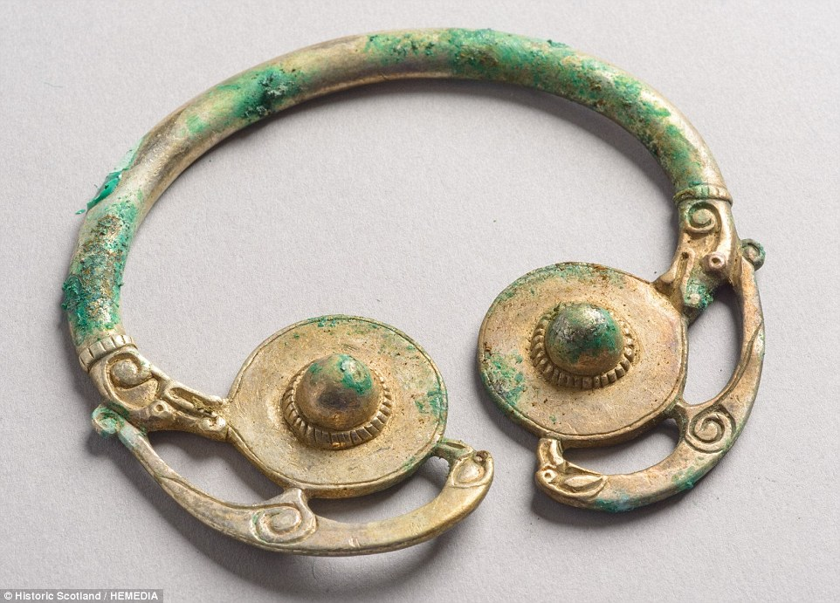 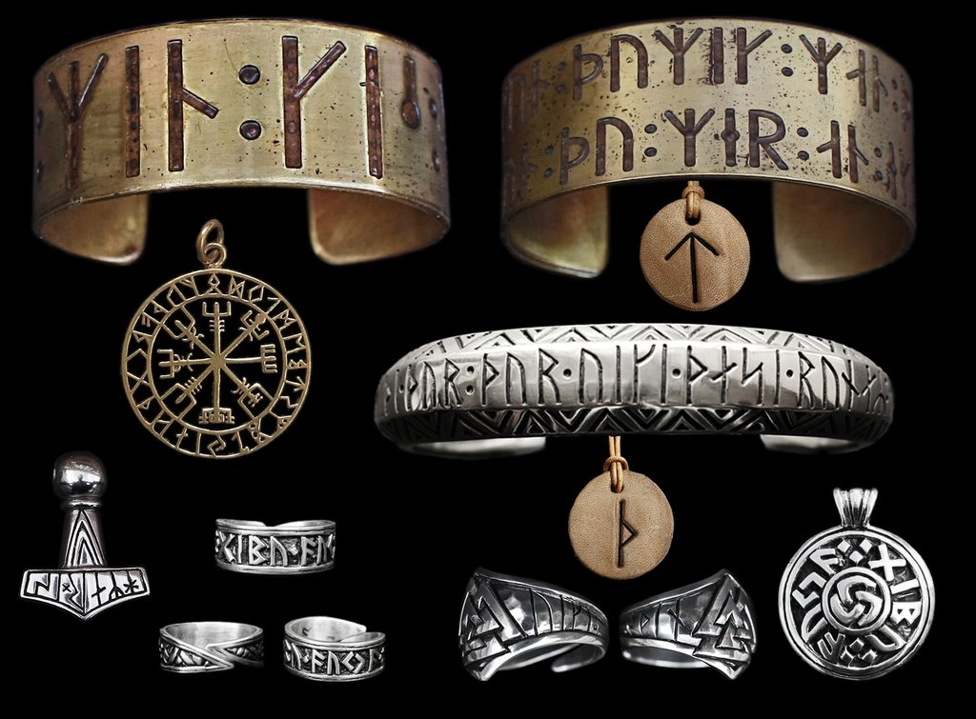

**I will be able to:**

* Reflect on existing artwork and designs and express my viewpoint
* Develop and experiment with ideas in my sketchbook
* Develop sketching/drawing skills
* Create my own design inspired by Viking jewellery
* Review and refine my ideas, developing my skills
* Add decoration to my work using clay

**I will know:**

Vikings took pride in how they presented themselves

Beautiful jewellery inspired by mythical beliefs was one of their trademarks

Both men and women wore jewellery

They wore rings, brooches, bracelets and necklaces to show their status

Poor people made jewellery out of bronze, pewter or the bones of the animals they ate

Rich people used precious silver and gold

What will I know by the end of this unit of work?

* Background knowledge about historical sources
* Background knowledge of Vikings
* How to use a sketchbook to explore and experiment with ideas
* Plan and refine drawings
* Some basic techniques using clay (rolling, pinching, kneading. coiling)
* The Vikings stem from Scandinavia, Norway, Sweden and Denmark. They invaded many countries including Great Britain and left traces of their culture.

Vikings - Vikings were **Norse** people primarily from southern Scandinavia, who from the late 8th to late 11th centuries, raided and traded across wide areas of Europe

Jewellery – personal ornaments, such as necklaces, rings, or bracelets, that are typically made from or contain jewels and precious metal

Brooch – is a decorative jewellery item designed to be attached to garments, often to hold them closed. It is usually made of metal, often silver or gold or some other material.

Barrette -  typically bar-shaped clip or ornament for the hair; a hair slide.

Ornate – elaborately or highly decorated

Refine – make minor changes to improve our work

Year: 4

What should I already know?

Waterloo Primary School – Art Knowledge Organiser