

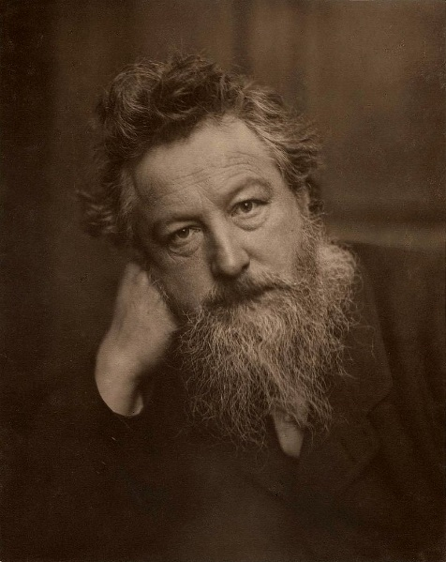 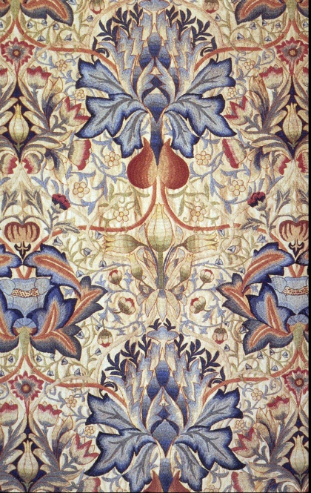 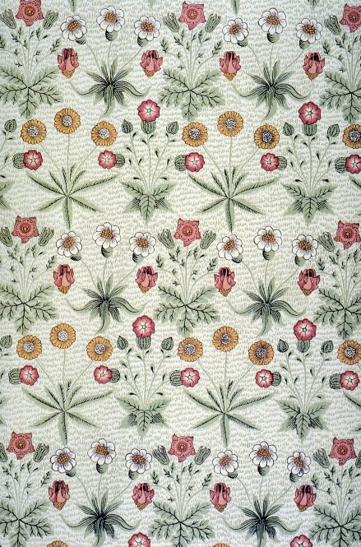

**I will be able to:**

* Use my sketch book to record observations and ideas **and** to revisit, review and edit my work
* Improve my drawing and sketching skills from observation
* Be more experimental with ideas and materials
* Create images inspired by nature
* Repeat images digitally and using block printing to make repeated patterns

**I will know:**

* William Morris was a Victorian textile designer
* He made patterned wallpapers, tapestries and stained-glass images
* he was inspired by nature (Victorians living in cities, surrounded by factories grew to miss nature)
* His images were repeated by block printing
* His designs are replicated and used today
* Today, advances in technology enable images to be repeated digitally and on mass.

Artist: William Morris

Year:5

* Textiles: Cloth or woven fabric
* Tapestries: a piece of thick textile fabric with pictures or designs formed by weaving coloured weft threads or by embroidering on canvas, used as a wall hanging or soft furnishing
* Interior Design: the art or process of designing the interior decoration of a room or building
* Influential: has influence over other people (had impact on other artists)
* Intricate: extremely complicated or detailed
* Digital technologies: electronic tools, systems, devices and resources that generate, store or process data
* Many artists have been inspired by nature
* The Industrial Revolution took place in the Victorian era
* How to use a sketchbook to explore and experiment with ideas
* Plan and refine drawings

Vocabulary

What should I already know?

What will I know by the end of this unit of work?

Waterloo Primary School – Art Knowledge Organiser

Autumn