

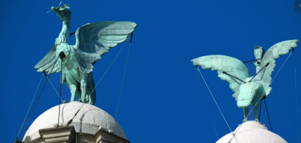

I will be ale to:

* Say why the Liverbuilding and the birds are designed by different people
* Improve the mastery of drawing and sketching skills from observation
* Record observations and ideas
* Experiement with tone and shape
* Review my work and improve it

**I will know:**

Carl Bernard Bartels designed the Liver birds (1911)

They are a mythical symbol and famous landmark of Liverpool

They stand on top of the clock towers of the Royal **Liver Building** at Liverpool's Pier Head, overlooking the Mersey.

Their names are Bertie and Bella. The male, Bertie looks over the city and the female, Bella looks to the sea.

The birds are made from copper

.

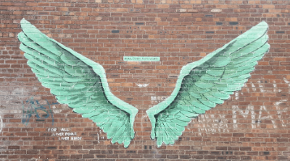

What should I already know?

Topic: Liver birds

Year:6

**Background** - the shapes that appear behind the foreground.

**Landscape** - a painting of nature and the land such as the ocean, mountains, trees, and sky.

**Technique**- the way you do something

**Perspective** - a way of painting or drawing that makes some objects appear closer than others.

**Observation** - drawing or painting from life

**Sketching**- drawing or painting often made as a 1st piece / draft, not the final artwork

Perspective – the art of representing objects with relative proportions

* That the Liver building is in the Pier head. The Liver birds are on top of the Liver building. The architect of the Liver building was [Walter Aubrey Thomas](https://www.google.com/search?safe=strict&q=Walter+Aubrey+Thomas&stick=H4sIAAAAAAAAAONgVuLUz9U3ME03y7J8xOjMLfDyxz1hKatJa05eYzTh4grOyC93zSvJLKkUUuNig7JkuHilELo0GKS4uRBcnkWsIuGJOSWpRQqOpUlFqZUKIRn5uYnFABtjAnBqAAAA).
* That when discussing art people have different views and opinions and it is good to back them up with reasons and evidence.
* Different techniques like hatching and shading to add texture.

Vocabulary

What will I know by the end of this unit of work?

Waterloo Primary School – Art Knowledge Organiser