

Vocabulary

Topic: Joan Miro - Surrealism

**Background** - The shapes that appear behind the foreground

**Technique** - the way you do something

**Surrealism –** an art style developed in the 1920’s in Europe, using the subconscious mind as a source of creativity. Often show unexpected or irrational objects in an atmosphere of fantasy, creating a dreamlike image

**Watercolour -** Refers both to the medium and works of art made using the medium of watercolour – a water soluble paint with transparent properties

**Pastel -** Pastels are sticks of colour used for drawing. The texture of pastels can be chalky or oily depending on what the pigment is mixed with. They are bright, portable colours with no drying time

**Bold –** strong, distinct**.** An **artist** with a **bold** style in **art** may often overstep and deviate from conventional rules

**Express/expressive -** refers to the feelings, moods, and ideas that are disseminated to the viewers by an **artist** through a work of **art**

**Reflection –** thoughts / opinions looking back at work

**Primary -** All other colours are made from these and they cannot be made by mixing other colours

**Secondary -** A colour made by mixing 2 primary colours

* How to use your sketchbook to record observations, to experiment with different techniques and to refine your ideas
* Different cultures influence different art
* Other people’s art influences new artists
* The same piece of artwork can be interpreted in different ways
* That primary colours can be mixed to create new colours

Year:6

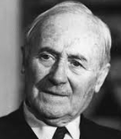 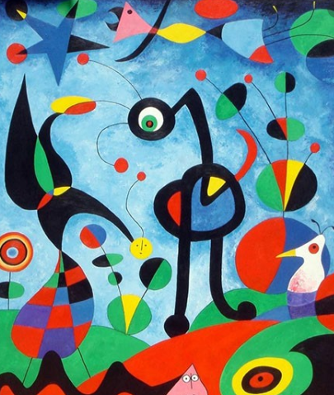 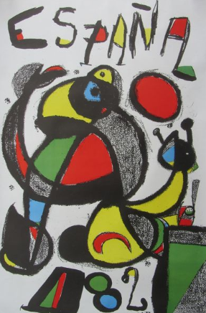

**I will be ale to:**

* Describe and respond to surrealism art
* Experiment and creative with ideas and materials
* Experiment with texture, tone, pattern, colour and shape.
* Create my own designs in the style of Joan Miro using a range of different media
* Review and refine my work.

**I will know:**

* Joan Miró i Ferrà (20 April 1893 – 25 December 1983) was a [Spanish](https://kids.kiddle.co/Spaniards) [painter](https://kids.kiddle.co/Painter), [sculptor](https://kids.kiddle.co/Sculptor), and ceramicist born in [Barcelona](https://kids.kiddle.co/Barcelona)
* Joan Miró started painting when he was fourteen; he attended an art school
* He then started to develop his own style, drawing scenes of trees and landscapes
* In around the 1930s Joan started to make rapid changes to his style of painting
* Influenced by [Pablo Picasso](https://kids.kiddle.co/Pablo_Picasso), Miro developed more [surrealist](https://kids.kiddle.co/Surrealist) works
* Miró was a significant influence on late 20th-century art, in particular the [American](https://kids.kiddle.co/Americans) [abstract expressionist](https://kids.kiddle.co/Abstract_expressionism) artists.

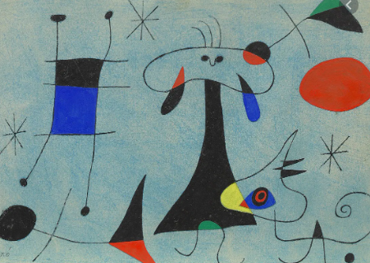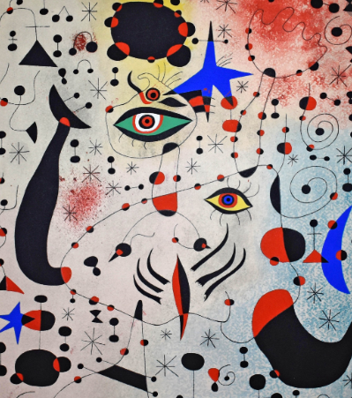

What should I already know?

What will I know by the end of this unit of work?

Waterloo Primary School – Art Knowledge Organiser