

Topic: The Royal Albert Dock

Year:6

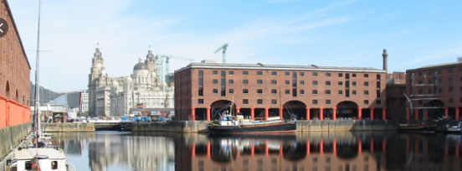

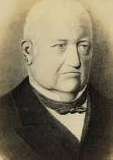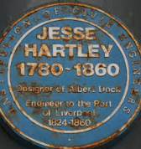

**I will be ale to:**

* Develop my observational drawing skills of the Albert Dock by developing areas of interest
* Create observational designs of the Albert Dock
* Experiement with texture, tone, pattern, colour and shape.
* Draw for a sustained period of time.
* Review my work and improve it.

**I will know that:**

* The Albert Dock (designed by Jesse Hartley)was opened in 1854
* It is now a bustling area of Liverpool with trendy wine bars, restaurants and souvenier shops
* At the time of its construction it was considered a revolutionary docking system because ships were loaded and unloaded directly from/to the warehouses
* Due to its open yet secure design, the dock became a popular store for valuable cargoes such as brandy, cotton, tea, silk, tobacco, ivory and sugar
* It was constructed using cast iron mixed with brick masonry

Knoweldge will be build through independent/group research

What should I already know?

**Background** - The shapes that appear behind the foreground

**Landscape** - A painting of nature and the land such as the ocean, mountains, trees, and sky

**Technique**- the way you do something

**Perspective** - A way of painting or drawing that makes some objects appear closer than others

**Observation** - drawing or painting from life

* The Royal Albert Dock is in Liverpool
* The works of some famous architects that have contributed to the Liverpool skyline
* Facts about the history of Liverpool, including links to the slave trade
* That people can interpret the same pieces in different ways
* Different techniques like hatching and shading to add texture.

Vocabulary

What will I know by the end of this unit of work?

Waterloo Primary School – Art Knowledge Organiser