

* How to create simple algorithms using Bee-bots/Codapillar.
* How to remote control cars.
* How to access games on interactive boards.
* How to photograph using iPad
* How to use software on computers to create representations of people and objects.
* How create representations of objects and people on interactive boards.

Vocabulary

**Algorithm** – steps to follow to achieve a task.

**Sequence**– a sequence of instructions that are followed in order.

**Program** –a sequence of instructions written to perform a specified task on the computer.

**Debug** – finding and correcting errors.

**Personal information**–information to be kept private such as address/name.

**Trusted Adult**– someone you have a good relationship with that you trust such as a teacher or parent.

**Online bullying**– a form of bullying using electronic means.

**Processor**- a machine that processes something (CPU).

**Digital** – any media created, edited or viewed on a computer.



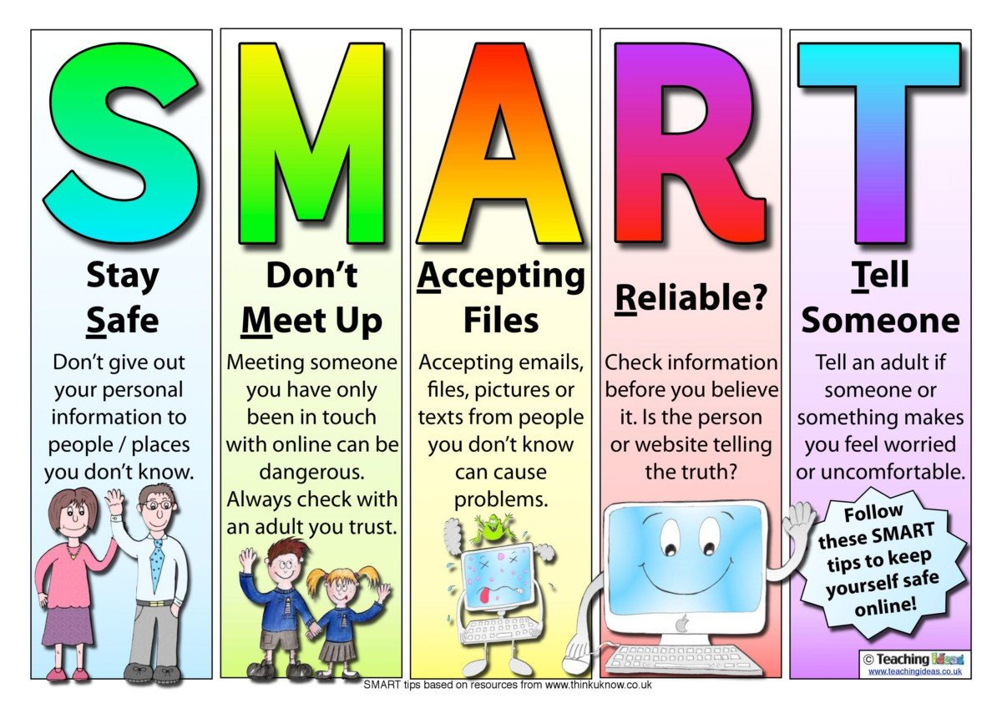

Understand the rules outlined by the school’s acceptable use policy.

Understand how to keep information private and why that is important.

I know common uses of technology beyond school.

I know that I must keep my information private and why.

I know how to keep my information private.

I know how to program Bee-Bot to follow a route

Topic: Digital Literacy

Year: 1

**Waterloo Primary School – Computing Knowledge Organiser**

What should I already know?

What will I know by the end of this unit of work?