

* How to access games on IWB and how to create representations of objects and people.
* How to photograph using an iPad and model how to retrieve information using search engines.
* To know how to use a keyboard to add own names to pictures created on computers.
* That a range of technology is used in places such as home and school –
* How to select and use these.

Vocabulary

**Algorithm** – steps to follow to achieve a task.

**Sequence**– a sequence of instructions that are followed in order.

**Program** –a sequence of instructions written to perform a specified task on the computer.

**Debug** – finding and correcting errors.

Personal Information–information to be kept private such as address/name.

**Trusted Adult**– someone you have a good relationship with that you trust such as a teacher or parent.

**Online Bullying**– a form of bullying using electronic means.

**Processor**- a machine that processes **something (CPU).**

**Digital** – any media created, edited or viewed on a computer.



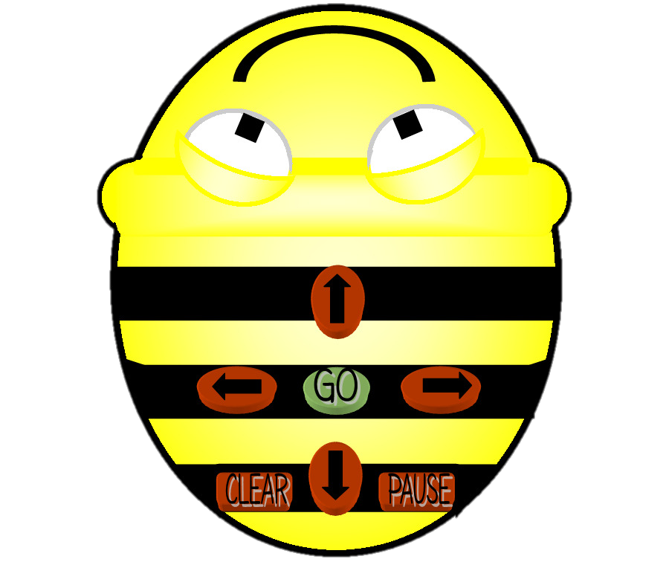

How to apply Maths knowledge of position and direction to Computing programs.

To understand that an algorithm is steps to follow to achieve a task – write a simple one.

I know how to create a simple program.

Topic: Computer Science

Year: 1

**Waterloo Primary School – Computing Knowledge Organiser**

What should I already know?

What will I know by the end of this unit of work?