

* How to gather information from the internet?
* That their work can be presented in different ways
* That the internet should be used safely.

Vocabulary

**Multimedia** – the use a variety of artistic or communicative media.

**Computer** – an electronic device which receives data and performs operations.

**Text** – the written word.

**Font** – the particular size and style of text

**Select** – highlighting chosen text or pictures.

**Paste** – places selected text or picture in desired location.

**Resize** – manipulate text or image to desired size.

**Boolean Operators** – they connect your search words together to either narrow or broaden your search.

**Search Engines** – programs that are designed to search the internet for us.

**Key Words** – selecting language specific to the topic you are researching.

**Computer** – an electronic device which receives data and performs operations.

**Listed Links** –the results are listed in order with the most popular being at the top.

**Algorithms** – a process a search engine uses to help find what you are looking for.

**I will be able to:**

* Select and use a variety of software.
* Select, use and combine a variety of software.
* Gather relevant information from the internet.
* Further develop research skills to present findings.
* Understand how Boolean operators can refine a search.
* To select suitable photos from their project and add them to their presentation

Pupils will be able to use a combination of research, their own records of their projects together with a Microsoft presentation to create a final piece.

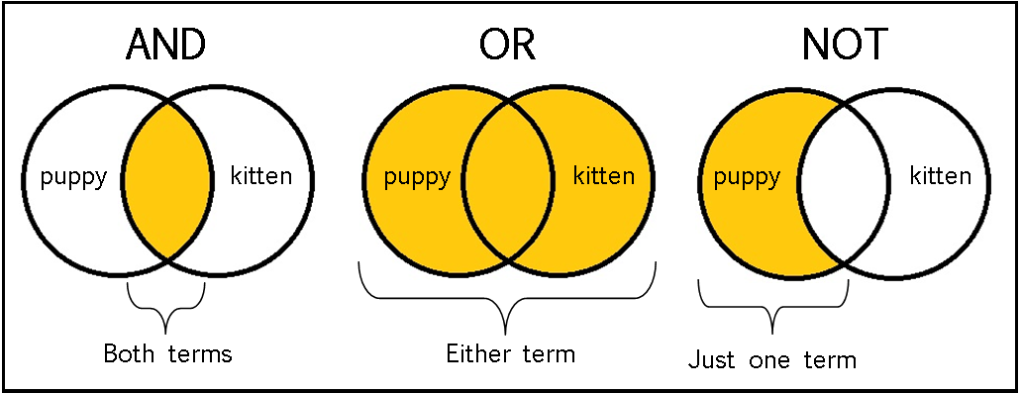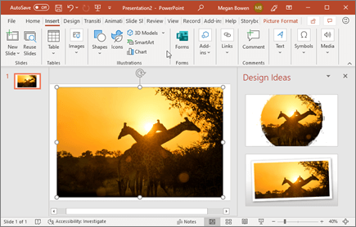

Topic: Information Technology

Year: 4

**Waterloo Primary School – Computing Knowledge Organiser**

What should I already know?

What will I know by the end of this unit of work?