



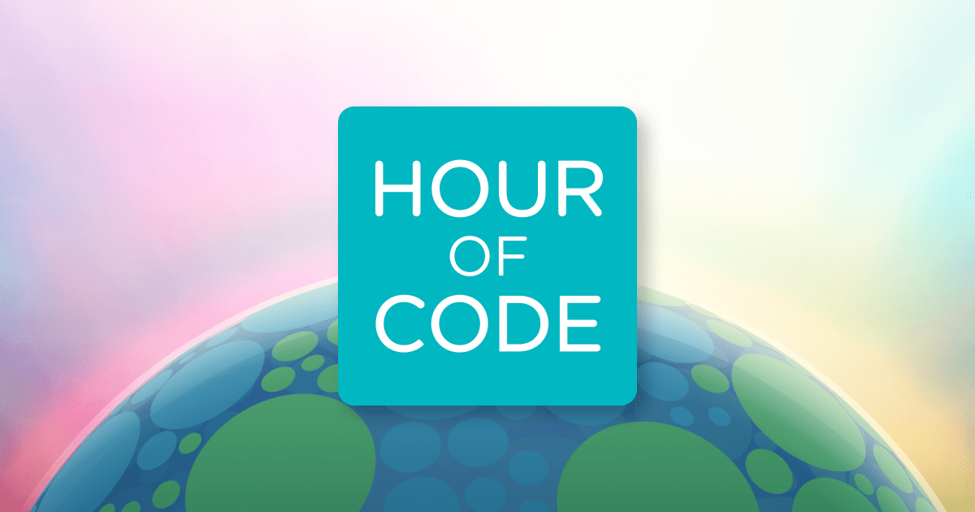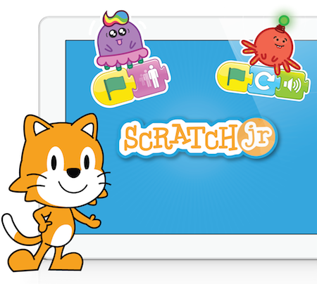 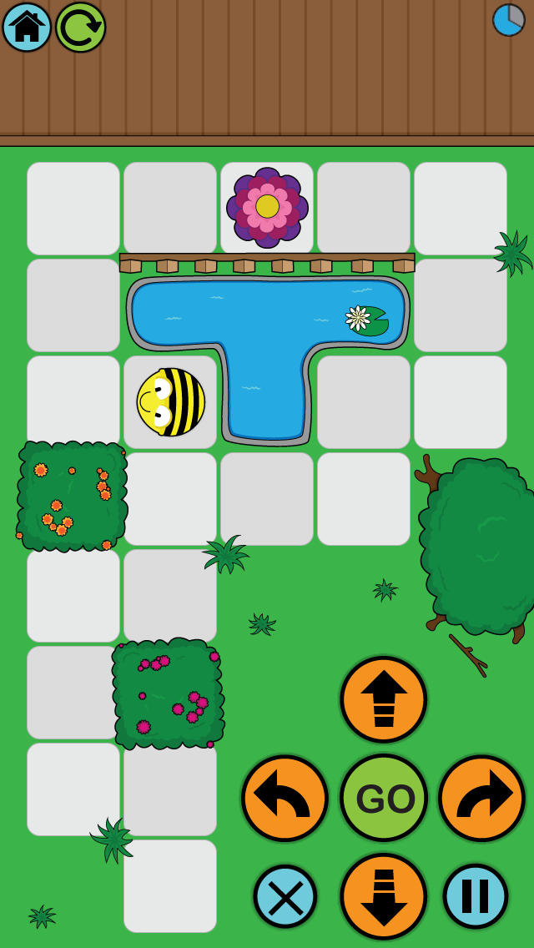

* Know how to create simple algorithms on the computer and other devices such as iPads (apps).
* Know how to find errors and debug simple algorithms.
* Know what the words algorithm, program and debug mean.
* Create algorithms and predict the outcome.
* Implement skills across a range of programs.

Input- a method of computers receiving data (keyboard, mouse etc).

Output – the information produced by a computer system, typically on screen, through speakers or on a printer. Also an action performed by the computer e.g. switching on a light, moving a turtle or sprite across the screen.

Software- computer programs and applications (apps).

Repeat/loop- instructions that can be repeated until a condition is met.

Debug – finding and correcting areas.

Programs– a sequence of instructions written to perform a specified task on a computer.

Algorithm – clear steps or instructions to follow to achieve a task.

Characters/avatars/sprite- an object that can be controlled by programming. Scratch projects are made up of objects called Sprites.

Vocabulary

General skills – turning on a computer, logging on and accessing some programs.

Some basic processing skills on Word or PowerPoint.

Understanding and identifying different technology.

Simple E-Safety rules and knowledge.

Simple coding.

What should I already know?

What will I know by the end of this unit of work?

Year: 2

Topic: Computer Science

Waterloo Primary School – Computing Knowledge Organiser