

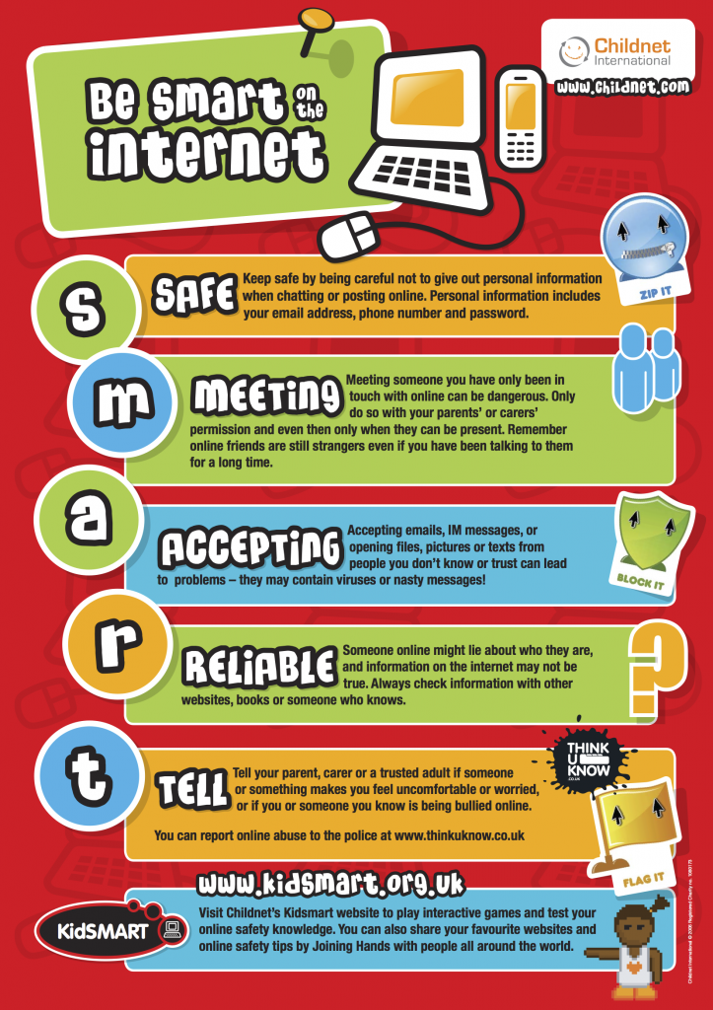

* Know how to recognise if a situation on the internet is safe.
* Know who to speak to if they have any concerns about their online safety.
* Know what information should be kept private.
* Know how to follow the school E-Safety rules.
* Begin to assess if something is trustworthy.
* Know how computers and a range of technology are used to communicate.

Browser – a computer program used to navigate the World Wide Web.

Computer networks – connected devices that make it possible to transfer data using an agreed method (protocol).

Input- a method of computers receiving data (keyboard, mouse etc).

Output – the information produced by a computer system, typically on screen, through speakers or on a printer. Also an action performed by the computer e.g. switching on a light, moving a turtle or sprite across the screen.

Software- computer programs and applications (apps).

WWW – World Wide Web.

Internet Safety- trying to stay safe on the internet and is the knowledge of keeping the user’s personal safe and security risks to private information.

Fictitious/Fake– something that is not real.

Vocabulary

General skills – turning on a computer, logging on and accessing some programs.

Some basic processing skills on Word or PowerPoint.

Understanding and identifying different technology.

Simple E-Safety rules and knowledge.

Simple coding.

What should I already know?

What will I know by the end of this unit of work?

Year: 2

Topic: Digital Literacy

Waterloo Primary School – Computing Knowledge Organiser