

Browser – a computer program used to navigate the World Wide Web.

Computer networks – connected devices that make it possible to transfer data using an agreed method (protocol).

Data – numbers that represent images, video, text and sound.

Computational thinking – an analytical approach to ‘problem’ solving.

Input- a method of computers receiving data (keyboard, mouse etc).

Output – the information produced by a computer system, typically on screen, through speakers or on a printer. Also an action performed by the computer e.g. switching on a light, moving a turtle or sprite across the screen.

Software- computer programs and applications (apps).

WWW – World Wide Web.

Vocabulary

General skills – turning on a computer, logging on and accessing some programs.

Some basic processing skills on Word or PowerPoint.

Understanding and identifying different technology.

Simple E-Safety rules and knowledge.

Simple coding.

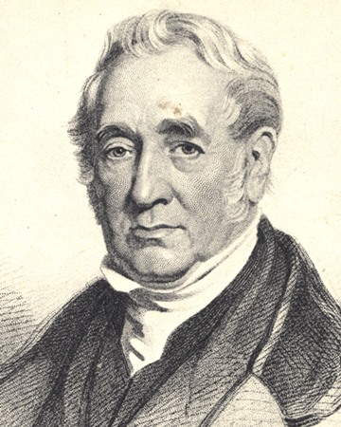 

* How to carry out a simple web search related to our ‘Transport’ topic.
* Understand the term WWW and begin to identify age- appropriate websites.
* Identify key facts and information to be used for their poster.
* Know how to create an information poster on Word building on previous learning from Year One.
* Apply and use a range of tools such as alignment tools, font styles, size, colours, text boxes and inserting pictures. Some children will experiment with borders and layout options.

What should I already know?

What will I know by the end of this unit of work?

Year: 2

Topic: Information Technology

Waterloo Primary School – Computing Knowledge Organiser