

* How to use the internet safely.
* Search engines help us to gather information.

Vocabulary

Boolean operators – they connect your search words together to either narrow or broaden your search

Search engines – programs that are designed to search the internet for us.

Key words – selecting language specific to the topic you are researching

Computer – an electronic device which receives data and performs operations.

Listed links –the results are listed in order with the most popular being at the top.

Algorithms – a process a search engine uses to help find what you are looking for.

**I will be able to:**

* Understand the importance of passwords
* Understand the need to keep personal information private
* Recognise the importance of being a good digital citizen.

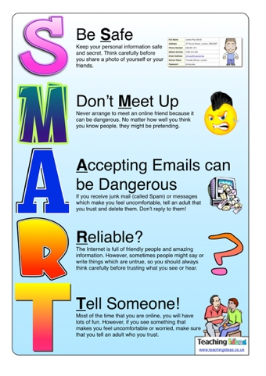

 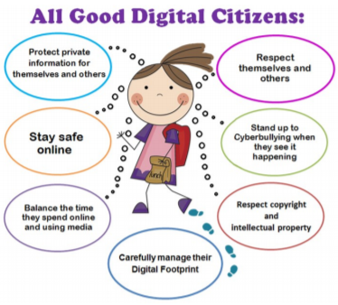

Topic: Digital Literacy

Year: 4

**Waterloo Primary School – Computing Knowledge Organiser**

What should I already know?

What will I know by the end of this unit of work?