

* That an algorithm is steps to follow to achieve a task.
* That algorithms can be implemented as programs on devices.
* What debugging is.
* That programs work by following a precise set of instructions.
* How to create simple programs and algorithms.
* How to predict outcomes in the algorithms I create.

Vocabulary

**Algorithm -** a process or set of rules to be followed in calculations or other problem-solving operations, especially by a computer.

**Sprite –** a computer graphic which may be moved on-screen and otherwise manipulated as a single entity.

**Control Block –** a segment of disk or memory that contains a group of codes used for identification and control purposes.

**Coding –** programming a computer **so that it understands** what to do.

**Command -** an instruction or signal causing a computer to perform one of its basic functions.

**Decomposition –** breaking a problem down into smaller parts to make it easier to tackle.

**Variable –** an element, feature, or factor that is liable to vary or change.

**Debug -** identify and remove errors from (computer hardware or software).

.

**I** **will know that:**

* Computers can be part of a network, and how these networks can be used.

**I will know how to:**

* Plan and write algorithms.

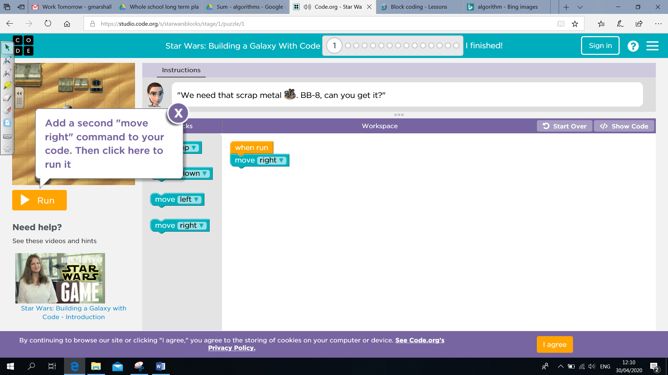

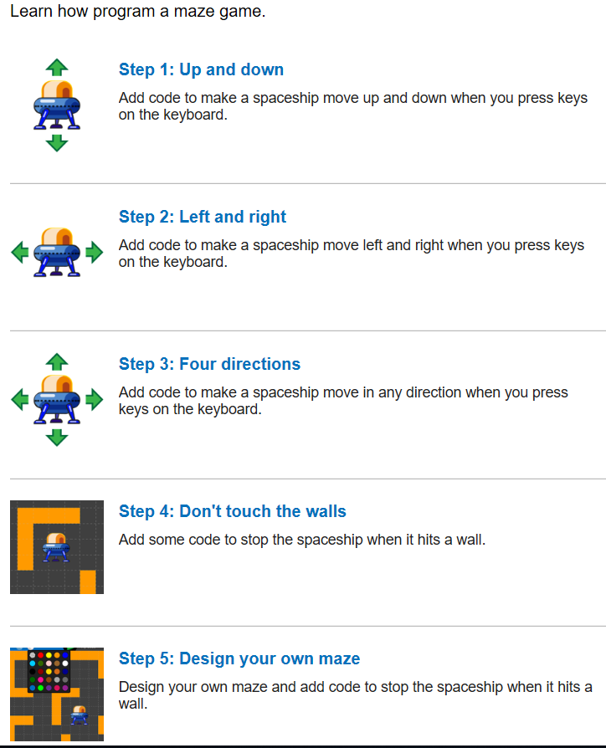

Topic: Computer Science

Year: 3

**Waterloo Primary School – Computing Knowledge Organiser**

What should I already know?

What will I know by the end of this unit of work?