

* How to keep my information private.
* Why it is important to use technology safely.
* How to program a Bee-Bot to follow a route.
* How to recognise if a situation on the internet is not safe and how to report it.
* That I must follow the school’s acceptable use policy.
* That computers and the internet are used to communicate.

Vocabulary

**URL -** the address of a web page.

**Untrusted -** a **party or system that may be malicious or unsafe.**

**Reliable -** consistently good in quality or performance; able to be trusted.

**Report -** give a spoken or written account of something that one has observed, heard, done, or investigated.

**Authenticate -** have one's identity verified.

**Verify -** make sure or demonstrate that (something) is true, accurate, or justified.

**Multimedia – integration of multiple forms of media.** This includes text, graphics, audio, video, etc.

**Network -** a group or system of interconnected people or things.

**Cyberbullying –** the use of electronic communication to bully a person, typically by sending messages of an intimidating or threatening nature.

**Blog -** a regularly updated website or web page, typically one run by an individual or small group, that is written in an informal or conversational style.

**I will know:**

* That it is important to report any concerns when using the internet and how I can do so.
* What acceptable online behaviour is.

**I will know how to:**

* Use technology safelyto keep information secure.
* Find out if a source is trustworthy.
* Create my own organisation for storing of files.

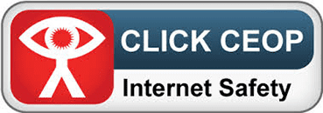

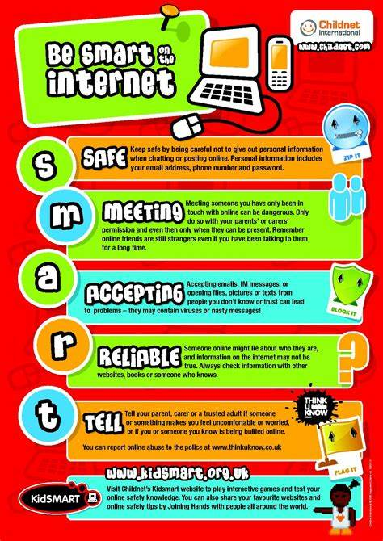

Topic: Digital Literacy

Year: 3

**Waterloo Primary School – Computing Knowledge Organiser**

What should I already know?

What will I know by the end of this unit of work?