

* How to search for a picture.
* How to search for information.
* How to save files with support.
* That a range of technology can be used to find information/pictures.
* How to use technology to create, store, and retrieve data.
* How to make a range of simple digital assets such as presentations, movies, audio files and graphs.
* How to navigate websites.
* How to carry out simple searches.

Vocabulary

**Simulation –** the production of a computer model of something, especially for the purpose of study.

**Sequence** - a particular order in which related things follow each other.

**Sprite –** a computer graphic which may be moved on-screen and otherwise manipulated as a single entity.

**Multimedia – integration of multiple forms of media.** This includes text, graphics, audio, video, etc.

**Control Block –** a segment of disk or memory that contains a group of codes used for identification and control purposes.

**Coding –** programming a computer **so that it understands** what to do.

**Complex –** consisting of many different and connected parts.

**Variable –** an element, feature, or factor that is liable to vary or change.

**Purpose -** the reason for which something is done or created or for which something exist

**I will know that:**

* Simulations mimic a real life scenario.

**I will know how to:**

* Use a range of software and devices to create content for a purpose.
* Use more complex simulations and understand the effects of changing variables.

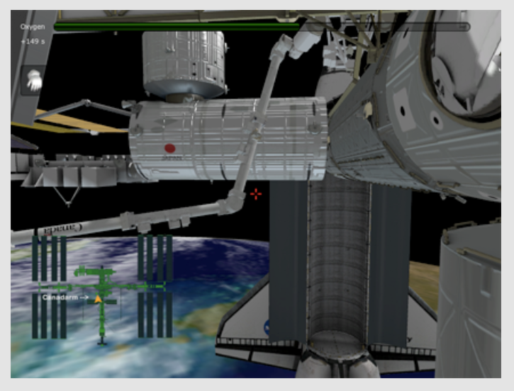

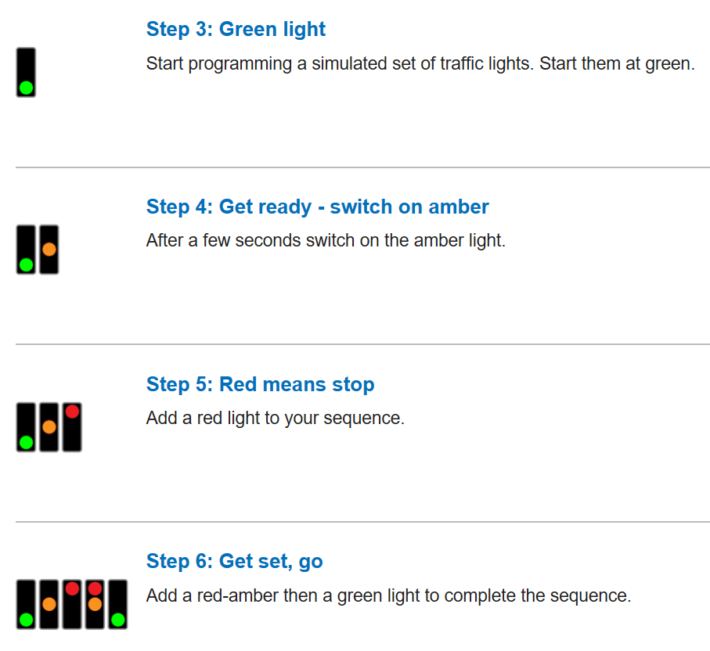

Topic: Information Technology

Year: 3

**Waterloo Primary School – Computing Knowledge Organiser**

What should I already know?

What will I know by the end of this unit of work?