

Cam - a roughly circular shape that creates movement

Handle - a part of a thing made specifically to be held by the hand

Slider - long and straight material that extends the movement of the cam

Follower - a component part that changes the plane of movement

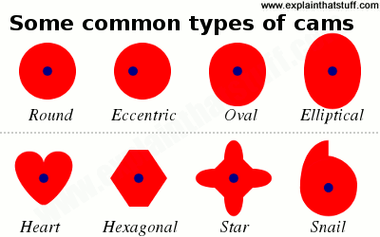

Vocabulary

* How axels and wheels work
* How to strengthen and stiffen structures

A **Mechanical system** has at least three elements: input, process and output

That cams, pulleys and gears can create movement

Know how to develop prototypes

Know how to produce a detailed list of the tools, equipment and materials that you will need

Know how to compare your ideas and products to your original design specification

Know to safely use a hacksaw and sandpaper

Know how to accurately measure and cut out to the nearest mm

What should I already know?

What will I know by the end of this unit of work?

Strand: DT

Waterloo Primary School – DT Knowledge Organiser

Year:5

Topic: Mechanisms