

Strand: Food Tech

* Knife – a kitchen tool used to prepare food throwing cutting
* Chop – cut something into smaller pieces
* Peel – remove the outside of something
* Slice – cut things into thinner pieces
* Healthy diet – eating a range of food that gives you the right amount of energy
* Ingredients – the food/ flavours used in a recipe
* Taste – one of our senses
* Planning – deciding what to use and what to do – getting ready

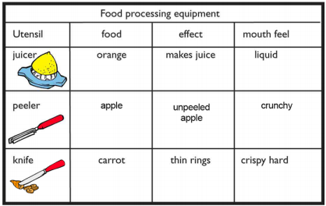

Vocabulary

Awareness of the need for a healthy diet

The importance of washing hands before preparing food

* How to consider my intended user (who the soup is for)
* Different cooking utensils have different purposes
* How to select from a range of tools
* How to handle a knife safely
* Where different foods come from
* All food comes from plants or animals
* That fruits and vegetables are a healthy part of our diets
* The names of different fruits and vegetables
* The names of the different food groups
* The importance of good hygiene
* How to handle and use a table knife safely

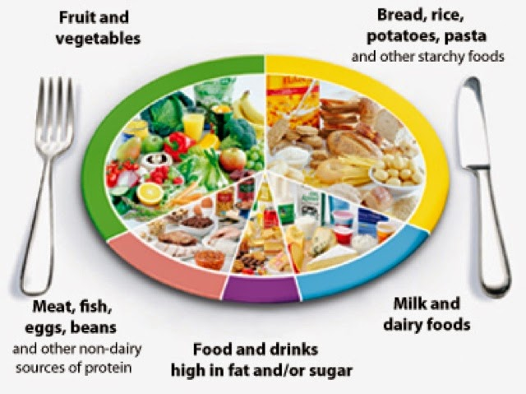

I will be able to:

* Talk about my salad, discussing what went well and it could be improved.

What should I already know?

What will I know by the end of this unit of work?

Waterloo Primary School – DT Knowledge Organiser

Year:1

Topic: Salad