

Vocabulary

* That different materials are used for different purposes
* That we can plan and evaluate our work
* I can consider my intended user

Template – a guide used to make something more accurate

Finish – how something is decorated at the end

Permanent – something that will last

Temporary – something that will last for a short time

Suitable – when something is right for a purpose

Fabric - cloth or other material produced by weaving or knitting fibres

Sew – to join 2 pieces of fabric with stiches

Seam – row of stiches, joining 2 pieces of fabric

* How to investigate and describe a range of puppets
* My products should have a purpose for being created
* My product will have an intended user
* That different fabrics h
* That I can select and use different tools for different jobs (cutting, shaping, joining and finishing)
* There is a difference between permanent and temporary fixing materials
* Glue is an example of a

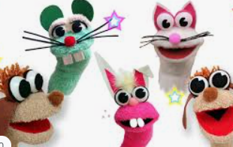

I will be able to:

* Use a template to cut shapes
* Use temporary joining such as paper clips
* Use permanent joining techniques such as stitches and glue
* Talk about what went well and what I could improve

What should I already know?

What will I know by the end of this unit of work?

Strand: Textiles

Waterloo Primary School – DT Knowledge Organiser

Year:1

Topic: Sock Puppets