

Template – a guide used to make something more accurate

Permanent – something that will last for a long time

Temporary – something that will last for a short time

Slider – a piece of card/wood used to slide in a slit in card

Lever – used to turn around a set point

Mechanism

Evaluate – talk about what went well and what could be improved

Finishing techniques – decoration (colour, glitter)

Vocabulary

* That different materials have different properties
* That different materials are fit for different purposes
* That my product will have an intended purpose and an intended user

Topic: Sliders and Levers (Titanic Book)

Strand: Mechanisms

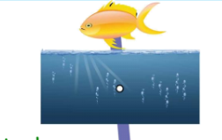

How to investigate existing products (a range of books for levers, sliders and flaps)

How to explain how sliders and levers work:

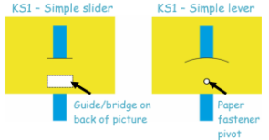

* How to select from and use different tools for different tasks (cutting, shaping, joining and finishing.)
* Understand different joins that can be used with paper and card (glue, tape, split pins, paper clips)

I will be able to:

Produce a labelled design

Evaluate my product, talking about went well and what could be improved

What should I already know?

What will I know by the end of this unit of work?

Waterloo Primary School – DT Knowledge Organiser

Year:1