

Vocabulary

Strand: Mechanisms

Topic: Wheels and Axels

Vehicle – something used for transport

Wheel – a circular object that allows something to move easily

Axle – a rod that attaches 2 wheels

Chassis - the steel frame, wheels, engine, and mechanical parts of a motor vehicle, to which the body is attached

Body - the main part of a vehicle

Permanent – something that is created to last

Friction – resistance caused when 2 things move against each other

* Different materials have different q1ualities which make them suitable for different purposes
* A mechanism is a system of parts that work together
* My products will have an intended purpose and an intended user
* I can evaluate my product by talking about what went well

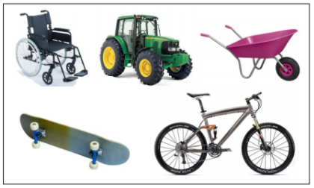

That existing product vary: the size, style, purpose, number of wheels, methods of fixing, materials…

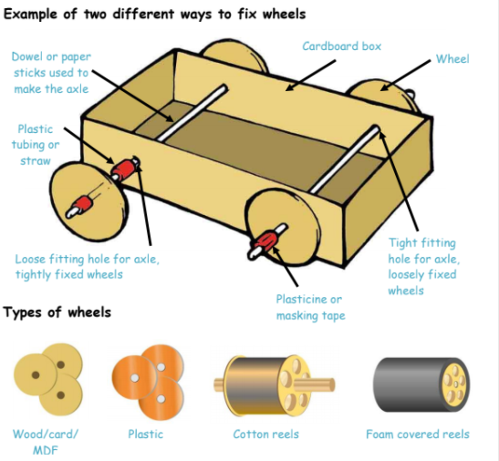

I will evaluate my product against my design criteria

What should I already know?

What will I know by the end of this unit of work?

Waterloo Primary School – DT Knowledge Organiser

Year:2