

* Healthy diet – a diet that provides us with the right amount of energy and nutrients
* Combine- mix together
* Flesh – the inside of a fruit or vegetable
* Skin- the outside of a fruit or vegetable, sometimes removed before cooking
* Seed- part of a fruit or vegetable that can be used to grow another plant
* Salad – a dish of cold cooked/raw fruits/vegetables
* Pith – soft white lining in fruits like oranges
* Sensory evaluation – evaluating smell/taste/texture

Vocabulary

Strand: Food Tech

*That food has to be grown, farmed or caught*

*That we should have 5 portions of fruit and veg everyday*

*That adult supervision is needed when using sharp tools*

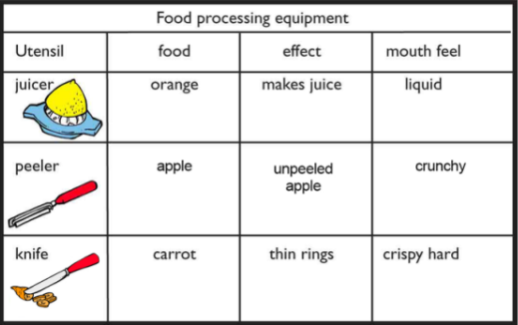

How to maintain good food hygiene: removing jewellery, tying hair back, rolling sleeves up, wearing aprons, washing hands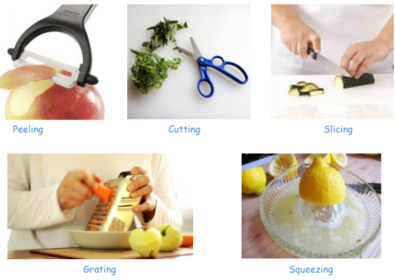

***understand where food comes from***

all food comes from plants or animals

***use the basic principles of a healthy and varied diet to prepare dishes***

name and sort foods into the five groups of the ‘eat well plate’

The importance of cleaning hands and surfaces

What should I already know?

What will I know by the end of this unit of work?

Waterloo Primary School – DT Knowledge Organiser

Year:2

Topic: Fruit Salad