

* Structure- a building or other object constructed from several part
* Framework- an important supporting structure of a building, vehicle, or object.
* Edge – the part of an object where two surfaces meet
* Surface- the outside part of an object
* Permanent- something that will last forever
* Temporary – something that will last for a short time
* Stability – how likely it is to fall over

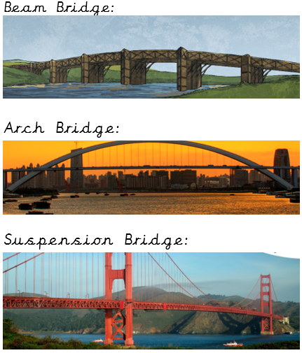

Vocabulary

How to use different joining techniques for card and paper

Strand: Structures

Facts about different types of bridges and what makes them strong

How to build a structure and how to make it stronger, stiffer and more stable

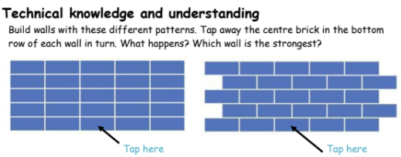

How to select from a range of materials according to their properties

How to select from a range of tools/equipment – explaining choices

How to make simple judgements about their products and ideas against design criteria

How to evaluate their products and components used

What should I already know?

What will I know by the end of this unit of work?

Waterloo Primary School – DT Knowledge Organiser

Year:2

Topic: Bridges