

* Shell structure – a structure with a hollow middle
* Net - the flat design of a structure
* Cube - a 3D shape
* Capacity- how much something holds
* Tabs- small pieces of a net used to attach the sides
* Adhesive – used to hold two things together
* Vertex – corners of a shape
* Scoring – cutting a line or mark into a shape to make it easier to fold
* Font – the style of lettering
* Face – the surface of a 3D shape
* Edge – where 2 surfaces of a shape meet

Vocabulary

* *How to use different cutting, joining and finishing techniques when working with paper and card.*
* *The names of some different 3D shapes*
* T*hat we can make free standing structures stronger and more stable.*

Topic: Fold away board game

Strand: Structures

* How to investigate a range of structures (including packaging) considering joins, materials, strength and stability
* That a 2D net can be folded and joined to make a 3D shape

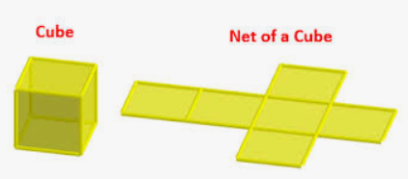

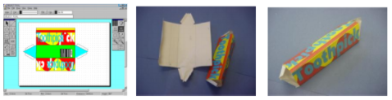

* How be really clear planning what the purpose of my product is and who my intended user is
* How to apply my knowledge of the properties of materials to make good choices
* How to use a ruler to measure accurately

How to strengthen and stiffen structures:

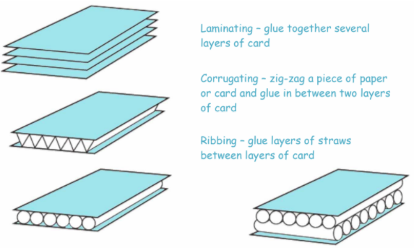

* and weaknesses within their ideas and product
* begin to consider the views of others, including the intended users, to improve their views

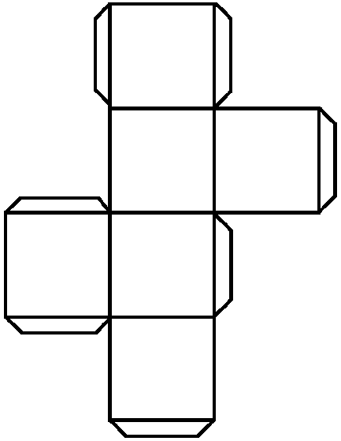net

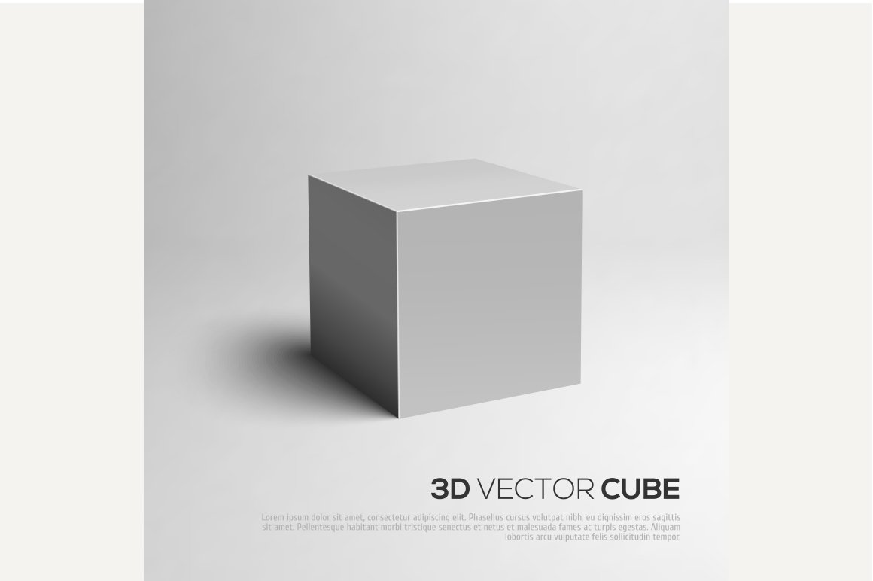cube

What should I already know?

What will I know by the end of this unit of work?

Waterloo Primary School – DT Knowledge Organiser

Year:3