

* Texture – how something feels
* Taste – the flavour of something
* Smell – the scent of something
* Savoury – the opposite of sweet
* Hygienic – keeping clean
* Edible – something you can eat

Grate -

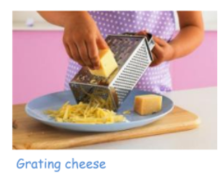

Bridge technique (to cut):

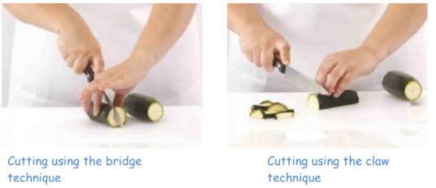

Claw technique (to cut):



Vocabulary

* That food has to be farmed, grown elsewhere or caught
* That everyone should eat at least 5 portions of fruit and vegetables every day
* Some ways of hygienically preparing ingredients

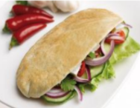

* *How to make my dish appealing*
* *Select ingredients based on appearance, smell and texture*
* *How to use different techniques for cutting (peeling, chopping, slicing, grating)*
* *How to complete a sensory evaluation*
* *understand seasonality, and know where and how a variety of ingredients are grown, reared, caught and processed*
* know that food is grown (such as tomatoes, potatoes and wheat), reared (such as pigs) and caught (such as fish) in the UK, Europe and the wider world
* That a healthy diet is made up from a variety and balance of different foods and drinks

What should I already know?

What will I know by the end of this unit of work?

Strand: Food Tech

Waterloo Primary School – DT Knowledge Organiser

Year:3

Topic: Pitta Pockets