

* *How to select from and use a range of tools and equipment to perform practical tasks (e.g. cutting, shaping, joining and finishing.)*
* That there is a difference between permanent and temporary fixing materials.
* different tools have different purposes.

Topic: Pencil Cases

* Fastening – used to close two pieces of fabric together
* Compartment – a pocket or space within something
* Seam allowance – extra material used to allow the product to stay the right size
* Template – used to draw around to make the product the correct size or shape
* Pattern – set of instructions for sewing
* 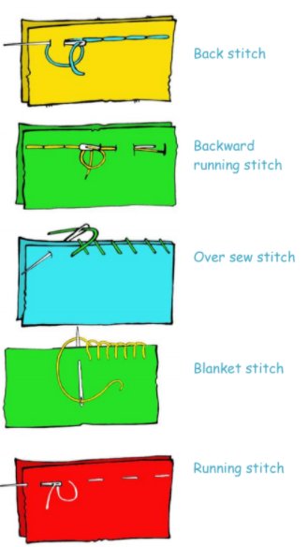

Vocabulary

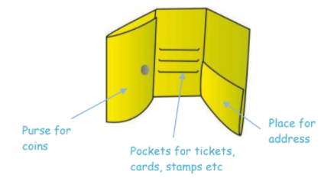

***How to describe a range of fabrics:***

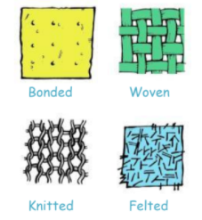

*How to select from and use a wider range of tools and equipment to perform practical tasks (e.g. cutting, shaping, joining and finishing) accurately*

That a single fabric shape can be used to make a 3D textiles product

How to generate ideas by talking, producing annotated sketches and prototype

How to order the main stages of your plan

How to apply a range of finishing/decorative techniques

How to evaluate my product using feedback from others

How to identify strengths and weaknesses

What should I already know?

What will I know by the end of this unit of work?

Strand: Textiles

Waterloo Primary School – DT Knowledge Organiser

Year:3