

Year: 4

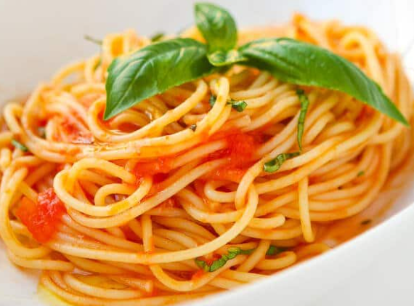

* To be active and healthy, a balanced diet is required to provide energy
* Some traditional Italian dishes
* How to measure in grams using digital scales
* How to use a garlic press
* How to use a vegetable knife, with adult supervision
* How to use a hob with adult supervision
* How textures of ingredients change when heated
* How ingredients can be adapted for your intended user
* That ingredients can be fresh, precooked and processed
* Complete a sensory evaluation, making suggestions for improvements.

Seasonal – the times of the year when harvested food is at its peak, e.g. tastes the best.

Texture – the properties of food that are sensed by the mouth and hands e.g. chewy, sticky.

Savoury – the opposite of sweet or salty food, e.g. bread

Pre-cooked – food that has already been cooked in advance and can either be eaten cold or heated for a shorter time before being eaten.

Processed – the transformation of grown and reared products into food.

Reared – animals that are bred and used for the purpose of eating.

Harvested – gathering of crops (fruits, vegetables, grains) for the purpose of eating.

Caught – animals that are caught for the purpose of eating e.g. fish.

Vocabulary

All food comes from plants and animals and must be farmed, grown or caught, either in the UK or around the world.   
  
A balanced diet includes food from all nutrient groups. Humans should eat 5 portions of fruits and vegetables every day.

Food needs to be prepared safely and hygienically.

What should I already know?

Topic: Italian Dish

What will I know by the end of this unit of work?

Waterloo Primary School – DT Knowledge Organiser