

Fault – an error that causes the electrical flow or current to be disrupted, so that the circuit is not successfully complete.

Connection – connects components in a circuit together and allows for electricity to flow through the circuit e.g. crocodile clips.

Toggle – a switch that has two positions e.g. on or off.

Switch – a component in a circuit that can be used to interrupt the flow of electricity. They are either closed (on) or open (off).

Push-to-make switch – a button which allows electricity to flow when held in.

Battery – produces electrical energy.

Battery Holder – holds the battery in place, so that it can be connected to other components within a circuit.

Bulb – produces light using electrical energy.

Bulb Holder – holds the bulb in place, so that it can be connected to other components within a circuit.

Crocodile clip – connects components within the circuit and allows electricity to flow through.

Insulator – material that does not allow electricity to flow through.

Conductor – material that allows electrical energy to flow through.

Program – a series of instructions to control a computer or machine.

Control –

Topic: Electrical Night Light

Vocabulary

Many common appliances run on electricity.

The basic parts of a circuit (bulb, battery, wires, switch, buzzers) and know how to construct a simple circuit.

Some common insulators and conductors and know that many metals are good conductors of electricity.

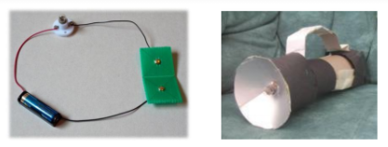

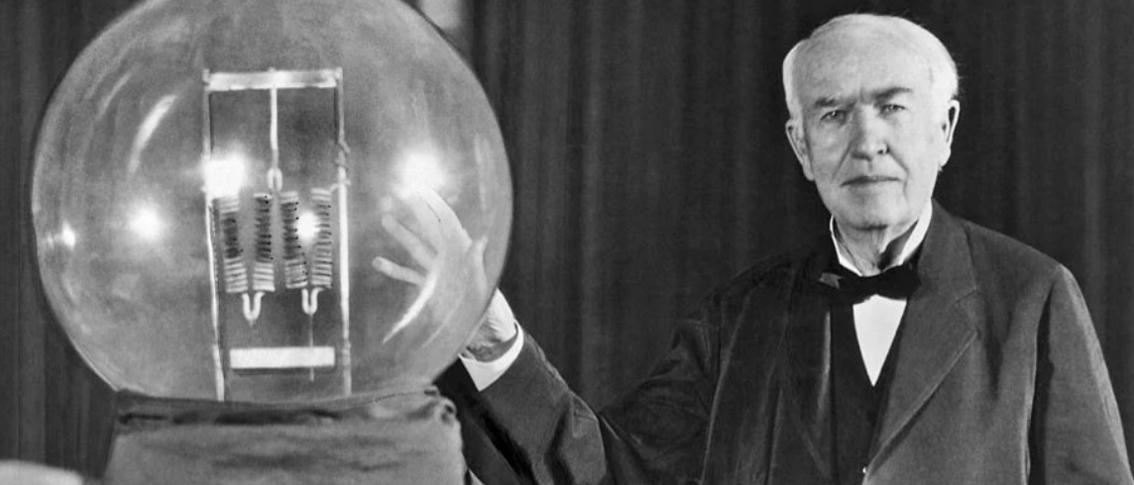

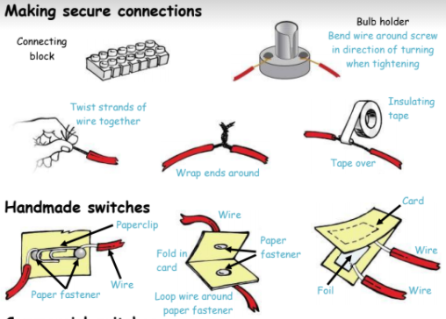

Electricity will flow when a circuit is complete.

Some symbols for the parts of a circuit.

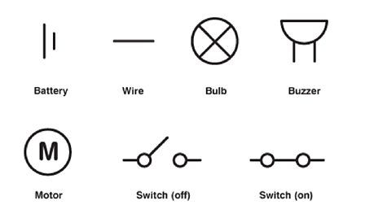

What will I know by the end of this unit of work?

Year: 4

What should I already know?

Waterloo Primary School – DT Knowledge Organiser