

Topic: Levers and linkages

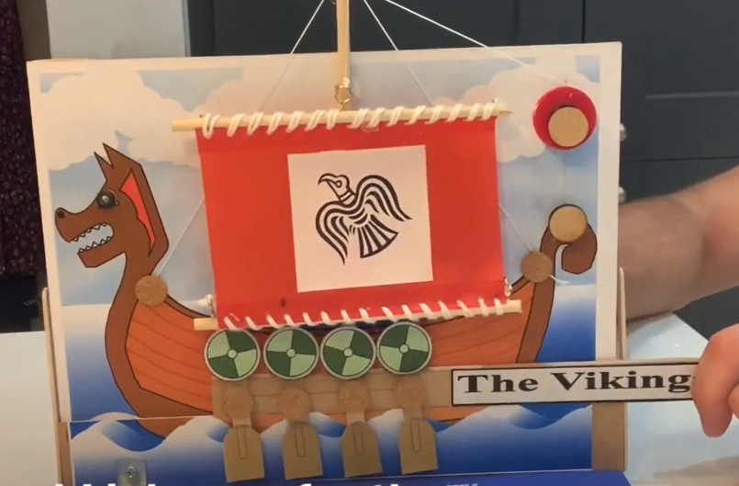

How to use simple levers and linkages

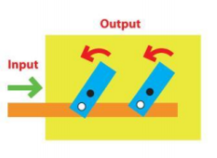

* The difference between loose and fixed pivots
* How to share and clarify ideas through discussion
* How to produce detailed, annotated plans
* How to make a detailed list of the tools and equipment that will be needed
* How to mark out measure and cut
* How to select tools and explain choices

What will I know by the end of this unit of work?

Vocabulary

How to investigate mechanisms and levers and how they are all around us.

That ideas take time to be developed and thought through.

Plan and refine plans and designs.

Mechanism -  system of parts working together in a machine; a piece of machinery

Pivot – the central point that a lever rests on

Push – applying a force to move something away

Pull - applying a force to move something closer

Lever – a rigid bar resting on a pivot, used to move a heavy or firmly fixed load with one end when pressure is applied to the other.

Design – a plan or drawing produced to show the look and function or workings of a building, garment, or other object before it is made.

Refine – make minor changes so as to improve our work

Year: 4

What should I already know?

Waterloo Primary School – Art Knowledge Organiser