

* **Pre-cooked** - prepared and cooked in advance so that it only needs to be heated before you eat it.
* **Processed** - mechanical or chemical operations performed food to change or preserve it.
* To be active and healthy food is needed to give the body energy

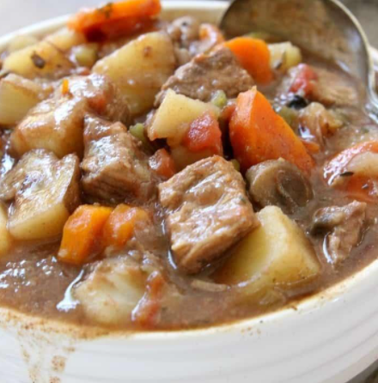

* Times of year when the harvest or the flavour of a given type food is at its peak (seasonality)
* How to select and use the correct **utensils** (the tools we use in the kitchen)
* That different foods contain different substances - nutrients, water and fibre - that are needed for health
* The need for correct and safe food storage
* How to carry out research (surveys, interviews, questionnaires and web-based resources)
* How to formulate step-by-step plans as a guide to making
* How to measure accurately using analogue scales
* How to prepare and cook scouse using a hob and vegetable knife (adult supervision)
* How to Carry out a sensory evaluation
* Evaluate - considering cost and suitability

Topic: Food technology

Scouse/Blind Scouse

**Culture** – People from different cultural backgrounds eat different foods.

**Fat** – fuel for the body

**Sugar** - sweet-tasting, soluble carbohydrates

**Carbohydrates** – provide energy and are found in starches and sugars

**Protein** - essential for building, maintaining, and repairing the tissues in our body.

**Vitamins** - 'vital for life' your body needs them to work properly.

**Nutrients -** include proteins, fats, carbohydrates, vitamins, and minerals

**Varied** – mixed, different

**Gluten** – found in flour

**Dairy** - containing the milk of mammals

**Savoury**- not sweet in taste

Vocabulary

Year:5

Summer

What should I already know?

What will I know by the end of this unit of work?

Waterloo Primary School – DT Knowledge Organiser