

* How to apply my understanding of computing to program, monitor and control their products
* How complex electrical circuits and components can be used to create functional products
* How to use a computer to control a product
* How to program a computer to monitor changes in the environment

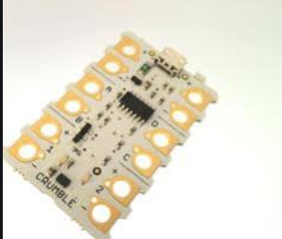

Series Circuit - circuit where the current flows through one path

Parallel circuit - circuit where the current flows through multiple paths

Input device - hardware that sends data to a computer

Output device - receives data from a computer

System-An interconnecting network

Algorithm-A set of rules to be followed

Flowchart-A diagram showing a sequence of necessary movements involved in an activity

Push to make switches- simple input devices which allow electrical current to flow when pushed.

* How to use basic computer-aided design
* How to formulate step-by-step plans as a guide to making
* That algorithms are used as a set of instructions for a computer system.
* how simple electrical circuits and components can be used to create functional products

Vocabulary

What should I already know?

What will I know by the end of this unit of work?

Strand:Electronics

Waterloo Primary School – DT Knowledge Organiser

Year:6

Topic: CAD