

That 3D textile products can be made by joining pieces of fabric

Different types of fasteners:

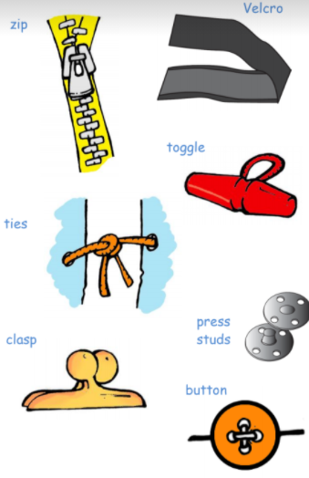

Different finishing techniques:

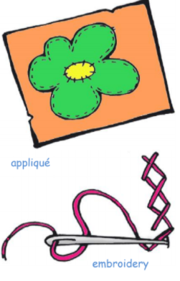

* How to use different types of stitch
* How to make refinements after completion
* How to analyse a product again a given criteria

**Wadding** -a layer of insulation between fabrics

**Right side** - When instructions mention the "right side" of fabric, they are talking about the "printed" or "pretty" surface of the fabric.

**Hem** - the very bottom, folded edge of a piece of **clothing**

Mock- up – a 3D model (practice go)

Seam allowance – extra fabric added on to join

Different types of stitch:

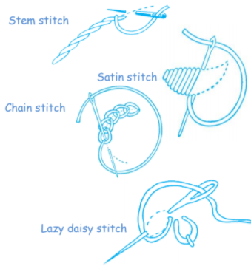

Vocabulary

How to use a basic stick to join pieces of fabric

How to use different finishing techniques

Topic: Textiles – shopping bag

Year:5

Autumn

What should I already know?

What will I know by the end of this unit of work?

Waterloo Primary School – DT Knowledge Organiser