

* Know that a recipe can be adapted by adding or substituting one or more ingredients
* Know that recipes can be adapted to change the appearance, taste, texture and aroma
* How to out ratios in recipes

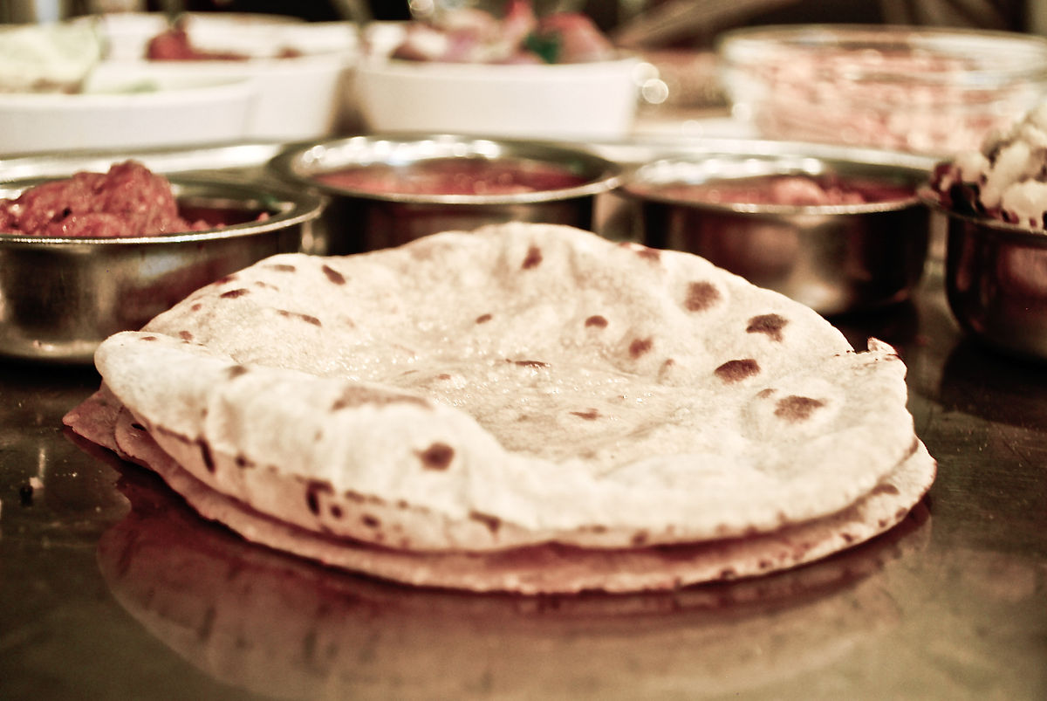

* How to research and plan, taking into account availability, cost and dietary requirements
* Where ingredients are sourced from and what the nutritional value is
* How to carry out a sensory investigation of existing products
* Compare recipes from key chefs

**Gluten-** the protein within cereal grains and wheat

**Dairy-**containing or made from milk

**Savoury-** food that is salty or spicy rather than sweet

**Utensils-** a tool, container or other article for household use

**Knead -** to work dough with hands

**Intolerance-** An inability to eat a specific type of food

**Combine-** join together to create one substance

**Fold-** using a spoon to turn over ingredients until they are combined

Vocabulary

* How to prepare food hygienically
* How to measure accurately using analogue scales
* Different food groups and the importance of healthy and varied diet

What should I already know?

What will I know by the end of this unit of work?

Strand: Food Tech

Waterloo Primary School – DT Knowledge Organiser

Year: 6

Topic: Chapatti