

Stiffen- To support, strengthen and make rigid

Frame Structure- Structures which have the ability to resist a gravity load

Strengthen- To make stronger

Reinforce- Strengthen or support with an additional material

Shape- To give form to an object

Join- connect or link things together

* How to select from and use tools (e.g. cutting, shaping, joining and finishing)
* How to accurately measure to nearest cm/mm, mark out, cut and shape materials and components
* How to strengthen and stiffen structures

Vocabulary

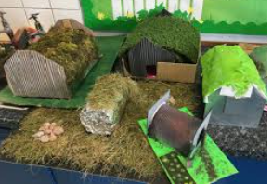

How to use techniques that involve a number of steps for finishing and joining accurately

How to refine design and explain reasons for refinement

How to explain choice of materials and components according to functional properties and aesthetic qualities

* consider the sustainability of materials and components used and offer alternatives where available.
* Generate innovative ideas, drawing on research whilst continuously analysing and thinking critically
* Make design decisions, taking account of constraints such as time, resources and cost and working to reduce these where possible
* Develop more complex and detailed prototypes
* Formulate step-by-step plans as a guide to making their product and adapting during the completion if necessary
* produce a detailed list of tools, equipment and materials that they need drawing on their understanding whilst thinking creatively and critically about their choices. If necessary, making adjustment

Strand: Structures

What should I already know?

What will I know by the end of this unit of work?

Waterloo Primary School – DT Knowledge Organiser

Year:6

Topic: Air raid shelters