

|  |  |
| --- | --- |
| Coordinates | Numbers given to help locate somewhere on a map |
| Ordnance Survey | The national mapping agency for Great Britain |
| Key | Gives you information about symbols and features on a map |
| Grid reference | Numbers used to locate places and features on an OS map |
| Points of a compass | any of the main points of a compass: north, south, east, west, north-east, north-west, south-east, south-west |

Vocabulary

* Locate countries on a world map
* Use 4 figure compass directions 4
* Use 4 figure grid references
* Use some OS symbols

I will be able to:

* Use 8 figure compass points (N, NE, NW, S, SE, SW, E, W)
* Use 6 figure grid references to accurately locate OS Symbols on a map

In this case the tourist information centre would be at 476334

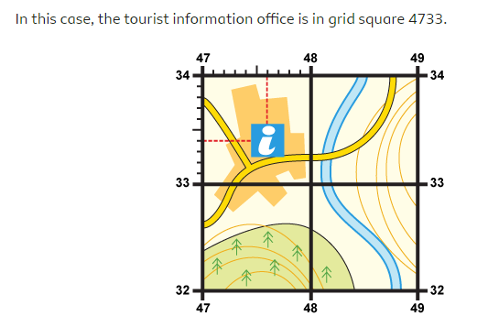

I will know:

* Some more OS symbols: public house,

caravan site, church with a tower/spire, woodland area, footpath, railway line, main road, bridge, quarry, golf course, campsite

* How to identify the position and explain the significance of longitude and latitude and Prime Greenwich Meridian and time zones (including day and night)

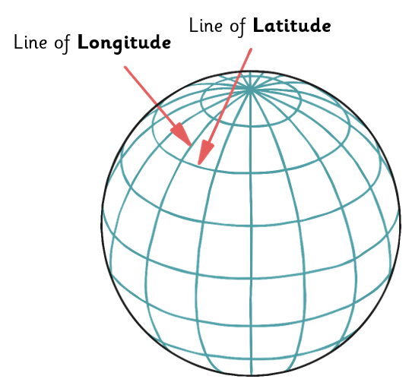

What should I already know?

What will I know by the end of this unit of work?

Waterloo Primary School – Geography Knowledge Organiser

Year: 5 Autumn

Topic: Map Skills