

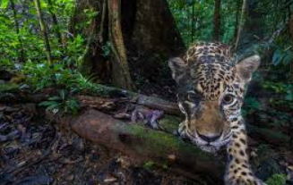

I will know:

* The Amazon is 5,500,000 square kilometres of rainforest, with parts in Brazil, Peru, Colombia, Venezuela, Ecuador, Bolivia, Guyana, Suriname and French Guiana
* Home to about 2.5 million insect species, tens of thousands of plant species, and over 2,000 species of birds and mammals
* Human activity is having a negative impact on the rainforests
* Many species are at risk of extinction
* Non-renewable energy sources include solar, wind and water
* Renewable sources are better for our environment than non-renewable sources (coal and oil)
* We all a part to play in conservation

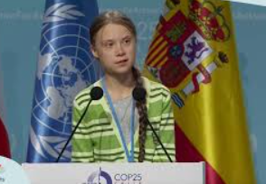

* The Amazon Rainforest is the largest rainforest and is located in South America
* Human activity can negatively impact on our environment

What should I already know?

Topic: Rainforest/Conservation

Biomes - a large naturally occurring community of flora and fauna occupying a major habitat, e.g. forest

Fair Trade – trade between companies in developed countries and producers in developing countries in which fair prices are paid to the producers

Climate - the average weather conditions over a long period of time

Deforestation - the cutting down and clearing of forests.

Humid - feeling very damp due to water vapour in the air

Native tribes - the original settlers of an area

Species - a group of similar animals or plants

Climate Change – a term used by experts when describing the way that both weather and climate systems are changing as a result of mankind’s industrial activity across the world

Renewable energy – energy created from natural sources

Vocabulary

What will I know by the end of this unit of work?

Year: 5 Summer

Waterloo Primary School – Geography Knowledge Organiser

­­­­­­­