

Rainforests - luxuriant, dense forest rich in biodiversity, found typically in tropical areas with consistently heavy rainfall

Amazon Rainforest - A rainforest in Brazil

Glaciers - a slowly moving mass or river of ice

Biomes - a large naturally occurring community of flora and fauna occupying a major habitat, e.g. forest

Fair Trade – trade between companies in developed countries and producers in developing countries in which fair prices are paid to the producers

Desert - A desert is a barren area of landscape where there is little precipitation, living conditions are hostile for plant and animal life

Iceburgs - a large floating mass of ice detached from a glacier or ice sheet and carried out to sea

I will be able to:

* Locate South America, some of its countries and capital cities
* Locate the Amazon River and Rainforest

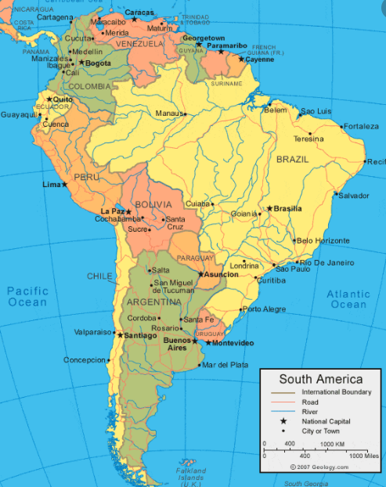

I will know:

* South America is a huge continent and so the climate can vary depending on where you are
* The Amazon Rainforest is the largest rainforest and is located in South America
* The Andes is the world’s largest mountain range and is located in South America
* Some key geographical features of countries of South America: rivers, mountain ranges, volcanoes, glaciers, statues, stadiums, beaches, waterfalls, biomes, city centres, deserts, rainforests, iceburgs, resources and trade

Vocabulary

* How to locate some countries on a world map
* How to identify the position of equator/poles/northern and southern hemisphere
* The 7 continents

What will I know by the end of this unit of work?

Year: 5 Spring

Topic: South America

Waterloo Primary School – Geography Knowledge Organiser

What should I already know?

­­­­­­­

What physical and human features are more common in South America than Europe?

Investigate