
Vocabulary
- How to use different methods for data collection
- How to use graphs to record findings
- How to use bar charts, pictograms and line graphs
- How to evaluate the quality of evidence and suggest improvements
Population density – the number of people living in each unit of area

Population distribution – the pattern of where people live

Land use – what the land is used for, falls under 6 categories: Recreational, Transport, Agricultural, Residential & Commercial

Settlements – Places that are inhabited

Reliability – how trustworthy something is
Retail – the sale of goods to the public
Hospitality - businesses including hotels and restaurants
Leisure – business including entertainment and sport

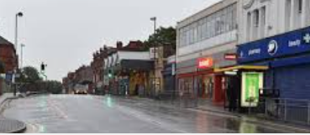
When considering, ‘Is our area fit for purpose?’ I will:
- Use fieldwork to observe, measure, record and present the human and physical features of an environment
- Use sketch maps and digital technologies
- Select and create appropriate measures to collect data
- Use databases to collect and gather information
- Present findings on graphs
- Evaluate the quality of evidence collected and suggest improvements
I will know:
- We can answer geographical questions using fieldwork
- We can measure and record in different ways
- We can present findings in different ways
- We can question the reliability of findings
- We can suggest improvements to increase reliability

What should I already know?
What will I know by the end of this unit of work?
Waterloo Primary School – Geography Knowledge Organiser
Year:6
Topic: Fieldwork

