

* Coordinates - numbers given to help locate somewhere on a map
* Ordnance survey - mapping agency for Great Britain
* Key - gives you information about symbols and features on a map
* Grid reference - numbers used to locate places and features on an OS map
* Compass points - north, south, east, west, north-east, north-west, south-east, south-west
* Continent - continuous expanses of land
* Capital - city or town where the government and main administration for the country are based
* County - division of some countries, forming the unit of local administration
* Hemisphere – (half of a sphere)
* Equator - a line drawn on the earth, dividing it into northern and southern hemispheres

Vocabulary

* How to use 8 figure compass directions
* How to use 6 figure grid references
* A range of OS symbols
* 7 continents and 5 oceans

I will be able to:

* Locate the world’s countries – focus on North America
* Use 8 figure compass accurately

(N, NE, NW, S, SE, SW, E, W)

* Use 6 figure grid reference accurately to locate features of Llandudno

In this case the tourist information centre would be at 476334

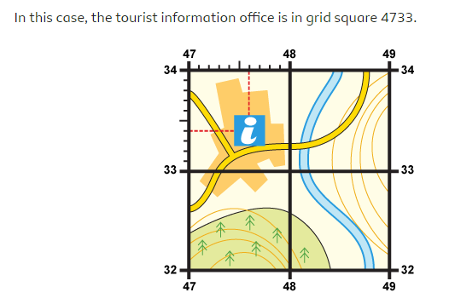

I will know (revision):

* A wider variety of OS symbols on an OS map
* 7 continents and 5 oceans
* Identify position and significance of longitude and latitude and the Tropics of Capricorn/Cancer
* The 4 countries, capital cities, counties of the UK and surrounding seas

What should I already know?

What will I know by the end of this unit of work?

Waterloo Primary School – Geography Knowledge Organiser

Year: 6

Topic: Map Skills/Revision